# THE TRANSFORMATION OF MICROFINANCE INSTITUTIONS IN AFRICA

John Karuitha a, b, c and Kalu Ojah a,*

**ABSTRACT**

Microfinance institutions (MFIs) have commonly operated as non-governmental organisations (NGOs) extending financial services to the poor without emphasising profits. However, the trend is the conversion of these NGOs to commercial or hybrid firms that stress both profits and outreach. We examine the drivers of the transformation of MFIs in Africa using a panel dataset of 705 MFIs. At the firm level, the age and size of MFIs influence the conversion while at the macro-level, financial development, legal tradition and institutional quality matter, with sizeable regional variations. The variables also interact in shaping the odds of transformation. The results have implications for policy development for sustainable MFIs for financial inclusion.

a Graduate School of Business Administration (Wits Business School), University of the Witwatersrand, Johannesburg, 2nd St David’s Place, Parktown, Johannesburg 2050, South Africa. <www.wbs.ac.za>

b Karatina University, School of Business, P.O. Box 1957, Karatina, 10101, Kenya. [www.karu.ac.ke](http://www.karu.ac.ke)

c Alliance for Social Research in Africa (ASRA),

* **Corresponding Author**, Email: kalu.ojah@wits.ac.za

## Introduction

The modern microfinance (MF) industry draws its popularity from the promise of providing appropriate and affordable financial services to segments of the population underserved by mainstream financial intermediaries (Morduch, 1999, 2000). The motivation for reaching out to the unbanked draws from researchers and development practitioners view that financial inclusion leads to welfare improvements for the poor. As examples, they associate access to finance to more business start-ups, higher savings rate, improved health, less child mortality, and higher education attainment by the poor, although other scholars dispute these findings (Klapper & Singer, 2014; O’Malley & Burke, 2017; Shahriar & Garg, 2017). Much of the initial efforts to provide financial services to the unbanked rested on microfinance, a term that refers to both the practice of providing appropriate and affordable financial services to the financially excluded and the providers of such services (Ledgerwood & White, 2006).

Pioneer Microfinance Institutions (MFIs), like Grameen Bank, mostly operated as Non Governmental Organizations (NGOs) and ran exclusively under the welfare approach, where the profitability of the institution played second to availing financial services to the poor (Chahine & Tannir, 2010; D’Espallier, Goedecke, Hudon, & Mersland, 2017). However, the paradigm shift is towards the financial systems approach where MFIs operate under market principles, leading to charges of “financialization” of poverty (Mader, 2015). The financial systems model, though more financially sustainable, is subject to “mission drift,” where an MFI lessens its commitment to availing financial services to the financially excluded in pursuit of profits (Jia, Cull, Guo, & Ma, 2016; Mia & Lee, 2017).

However, given the social mission inherent in MF, MFIs following the financial systems approach risk their legitimacy in the eyes of society and local and international donor community, a significant source of funding even for commercial MFIs (Nason, Bacq, & Gras, 2018). On the other hand, the NGO model, though not subject to mission drift, is over-reliant on volatile international donor funds and government subsidies (Garmaise & Natividad, 2013; D’Espallier, Hudon, & Szafarz, 2017). Additionally, NGOs may crowd out the efficient, market-based providers of microfinance (Kota, 2007), which may hurt aggregate welfare in the long run.

For these reasons, some scholars opine that it is possible to strike a balance between the two extremes. Adherents of the win-win approach attempt to reconcile the institutional and welfare approach, postulating that it is possible to achieve both financial sustainability (that is, turn a profit) and at the same time, reach the financially excluded (Kodongo & Kendi, 2013). As a case in point, some researchers argue that MFIs could strive to generate profits by offering financial services to the relatively well-off at market rates. The MFIs could then use the returns to subsidise the provision of financial services to the poor under a form of price discrimination, leading to “mission expansion” as opposed to mission drift (Mersland & Strøm, 2010).

Globally, the shift from the pure welfare approach of MF provision is gaining ground. Most of the transformed MFIs operate at some point on the continuum between the NGO, welfare model and the financial systems approach (Hishigsuren, 2006; D’Espallier, Hudon, & Szafarz, 2013). It all started in 1992 in Bolivia when Prodem, an NGO, converted to a commercial bank, Bancosol (Fernando, 2004; Creedy & Hoang, 2018). Since then, many MFIs across the world have converted from NGOs to commercial firms that also seek to make profits.

The objective of this article is to explore the factors that drive the transformation of MFIs from NGOs to for-profit firms in Africa. To this end, we use a panel dataset of 705 MFIs in Africa from the MIX pooled database, with additional data from the World Bank- the World Development Indicators (WDI), the Worldwide Governance Index (WGI), and the Global Financial Development Databases. We focus on Africa given the relatively low levels of financial inclusion on the continent (Demirguc-Kunt, Klapper, Singer, Ansar, & Hess, 2018), and the shortcomings inherent in combining data from different regions which may yield results that are not actionable in certain areas. As D’Espallier, Goedecke, et al. (2017) and Wang and Shailer (2015) suggest, the nature and performance of MFIs are country-specific. Hence, research focusing on particular regions, countries or even firms could better inform policymaking.

This article contributes to the literature in two main ways. First, the study sheds light on the drivers of the transformation microfinance institutions in Africa. Much of the literature has not examined this phenomenon, focusing on the consequences of the transformation and the way that MFIs can balance financial and social missions (D’Espallier et al., 2013; Forkusam, 2014; Mia & Lee, 2017). We believe that our analysis could form a reasonable starting point for analysing the transformation of MFIs in other regions or countries. Second, we detail the linkages between the drivers of the transformation of microfinance institutions, showing how they interact to change the likelihood of transformation. In so doing, we highlight the pitfalls that bedevil analysis that pools data from heterogeneous sources, which may mask crucial differences or similarities between the units of analysis.

The rest of the article is structured as follows. Section 2 presents the theoretical underpinnings and empirical findings related to the study. Subsequently, in section 3, we present a summary of findings, before delving into the method of analysis and results in sections 4 and 5, respectively. Section 6 concludes.

## Related Literature

Much of the early literature on the institutional transformation of MFIs dealt with the theoretical, philosophical, and historical basis for the transformation of MFIs from NGOs to commercial firms and the potential impacts of such conversion (Campion & White, 1999; Christen & Cook, 2001; Gutiérrez-Nieto & Serrano-Cinca, 2019; Zaby, 2019). Views of scholars regarding the transformation of MFIs drew from the institutional theory on the persistence and convergence in organisations as well as change and de-institutionalisation within firms (Scott, 2004) and the dominance of neo-liberalism after the cold war (Ostry, Loungani, & Furceri, 2017).

The institutional theory holds that the institutional environment is more influential in the development of formal structures in organisations than market pressures (DiMaggio & Powell, 1991). Coercion is one form of pressure from the institutional environment that makes organisations adopt given institutional structures and practices. Institutional theorists note that coercion could make firms adopt specific organisational structures and practices without critical scrutiny to gain legitimacy in the institutional environment (Scott, 2004; Martínez-Ferrero & García-Sánchez, 2017).

With this hindsight, Bateman (2010) traces the pressure to convert MFIs from NGOs to the commercial model to the rise of neo-liberalism and the insistence that firms be financially self-sustaining instead of relying on government subsidies and, in the case of MFIs, donor funds. The wave of economic liberalisation and privatisation that commenced in the early 1990s is a manifestation of neo-liberalism (Silva, 2018). Researchers point to pressure from financiers of MF such as USAID and the World Bank as a significant driver for the decision for MFIs to transform (Ostry et al., 2017).

However, given that MFIs have a social mission, the transition to a market-led positioning is bound to conflict with the social objectives and may threaten the legitimacy of the MF industry (Ramus & Vaccaro, 2017; Nason et al., 2018). Specifically, the quest to satisfy both financial objectives and the social mission is likely to conflict, which may cause “mission drift” (Mersland & Strøm, 2010; Mia & Lee, 2017).

Nonetheless, the push from donors for the transforming of MFIs seems to contradict with the slow pace of the transformation. NGOs still form a substantial proportion of MFIs in Africa, accounting for 32%, second only to Non-Bank Financial Institutions (NBFIs) at 40% (Microfinance Information Exchange (MIX), 2019). A question arises regarding the factors behind the persistence of certain organisational forms of MFI provision in Africa and across the globe.

Pashkova et al. (2016) tackled this question. They found that for instance, the cooperative model is prevalent in economies that have civil law systems, low levels of inflation and high economic growth rates. In contrast, NGO type MFIs feature in countries with high inflation rates and low levels of economic growth- meaning that NGOs assist the poor to cope during hard economic times. The commercial banking model features most in economies with common law legal systems. However, the study by Pashkova does not explicitly address the transformation question; factors that determine the transformation of MFIs from NGOs to a commercial model that are the subject of this article.

The capacity of the capital markets and its antecedents may raise the propensity for the transformation of MFIs. MFIs located in countries with well-developed capital markets can efficiently issue debt and equity instruments, and raise deposits from the public (Allen et al., 2013, 2014). Available literature points to legal tradition, governance and education as drivers of financial development in a country (Rajan & Zingales, 1998; Baltagi, Demetriades, & Law, 2009) and which, by extension drives economic growth as per the financial development-economic growth nexus literature (Claessens & Laeven, 2003). Also, the size of an MFI in terms of assets base, structure, and tangibility could enhance its capital acquisition capacity in line with the tradeoff theory of capital structure (Barclay & Smith, 2005; Gwatidzo & Ojah, 2009; Ojah & Ombati, 2016).

Ledgerwood and White (2006) attribute the financing structure, and hence the organisational form of an MFI to the institutional life cycle. In the early stages, for instance, most MFIs operate as NGOs relying on donations and concessionary funds, given that commercial funders deem them too risky. Later, they supplement their funding through government subsidies and equity funding from NGOs and public investors. In the final, consolidation phase, most MFIs rely on debt, using foreign donors as guarantees, and deposits, and increasingly adopt the commercial model. Thus, the age of an MFI has a bearing on both the capital structure and organisational structure, with firm-level, country and regional, disparities attributable to regulatory provisions relating to the ways MFIs can raise capital and historical legacies on saving and lending (Bayai & Ikhide, 2016) .

Nonetheless, it is the agency conflict that follows the introduction of debt and equity that brings to the fore the potential conflict between optimising financial returns and the quest to stick to the social mission of MFIs, in line with the agency theory (Nurmakhanova, Kretzschmar, & Fedhila, 2015; Bayai & Ikhide, 2016; Abdulai & Tewari, 2017; Awaworyi Churchill, 2018) which forms the second major strand of research on MFI transformation.

The next section highlights the results of the study.

## Summary of Results

The output from analysis of the data shows that at the country level, it is legal tradition, financial development, and, to some extent, governance (institutional quality) that relate to the likelihood of the transformation of MFIs. At the firm level, it is the age and size of the MFI that raise the probability of transformation with significant regional variations. GDP growth rate and education levels are not important determinants of the probability of transformation.

Precisely, the probability of an MFI transforming declines with the increase in age, while bigger MFIs have a higher likelihood of transforming. Capital market development/ financial development in a country also raises the probability of transformation, while, curiously, governance negatively relates to the chance of transformation. MFIs that operate in civil law countries and other legal traditions (like Ethiopia and former Portuguese colonies of Mozambique and Angola) have a higher probability of transforming compared to those that operate in common law countries. Regionally, compared to MFIs in Eastern Africa, MFIs in Southern Africa and central Africa are less likely to convert, while those in West Africa are more likely to transform although the relationship is not significant.

Nevertheless, results from the analysis of the pooled data masks some crucial insights. For instance, mature firms are more likely to transform than younger ones if they have more assets and are in countries with relatively high levels of financial development. On the other hand, the importance of MFI size in determining the probability of transformation reduces as financial development in a country rises. Also, governance raises the probability that an MFI would transform in West Africa but has the opposite effect in Central and Southern Africa. In the next section, we highlight the methodology applied in the study.

## Method

The article applies the panel mixed logit and mixed probit models where MFIs following the NGO model take a code of zero and one for NBFIs, credit unions/ cooperatives, and rural banks. Because the research focuses on the transformation from the NGO type to the variants of the commercial model, we do not utilise the multinomial logit. The next section lays out the model, together with the description of variables and data sources.

### 4.1 The Model, Variables Description and Data Sources

We use the model below to run both mixed logit and mixed probit regressions on a panel dataset of 705 MFIs in Africa.

$$f\left(x\right)=\ln\left(\frac{P_{i}}{{1-P}_{i}}\right)=β_{0}+β_{i}X_{it}+µ_{it}$$

The dependent variable is the current legal status of the MFI. The symbol $X_{it}$ represents a vector of independent variables- age, size, capital market development, legal tradition, GDP growth rate, institutional quality, and education. Additionally, we also include regional and time dummies. Table 1 below describes the variables in detail.

**Table 1: Description of variables**

|  |
| --- |
| **Indicator name, description, and data source** |
| **DEPENDENT VARIABLE** |
| **Current Legal Status:** We create a dummy with the MFIs following the NGO Model getting a code of zero, and one in the case of non-bank financial institutions (NBFIs), rural banks, and credit unions/ cooperatives. The data is available from MIX (See note 1). |
| **INDEPENDENT VARIABLES** |
| **Age:** The period in which the MFI has been in operation. MIX classifies MFIs into three groups; new, young, and mature. The variable enters the model as a dummy. |
| **Size:** We proxy the size of MFI with the natural logarithm of total assets, again using data from MIX. |
| **Capital Market Development / Financial Development (CAP):** We construct an index that captures both the quality and quantity of the financial sector of individual countries. We follow the procedure similar to that of Ito and Kawai (2018) by taking the first principal component index composed of bank credit, public and private debt market, and the stock market. The data source is the GFDD of the World Bank (See note 4). |
| **Legal Tradition (Legal):** The indicator is a dummy variable with common law countries coded 0, civil law countries 1, and 2 otherwise as per the classification by Oto-Peralías and Romero-Ávila (2014). |
| **GDP annual growth rate (GDP):** This is the year on year growth in output adjusted for inflation and sourced from the WDI (See note 2). |
| **Region:** As per the African Union (AU) classification, we allocate dummy variables to each of Africa’s regions; Eastern Africa, Central Africa, Southern Africa, West Africa, and North Africa. However, we exclude the African Diaspora in our analysis. Please refer to the AU handbook at <https://au.int/en/handbook> for the details. |
| **Governance/ Institutional Quality (KKM):** We take the first principal component of the WGI developed by Daniel [Kaufmann, Aart Kraay and Massimo Mastruzzi](http://siteresources.worldbank.org/DEC/Resources/ResponseToKnackLangbein.pdf) (KKM) (See note 3). |
| **Education (EDUC):** The indicator is a ratio of the gross enrolment in secondary school to the gross primary school enrolment as defined in the literature (Allen et al., 2013, 2014) |
| **Notes:**   1. The Microfinance Information Exchange (MIX) data on microfinance institutions across the globe, [www.themix.org](http://www.themix.org). 2. The World Development Indicators (WDI) database of the World Bank is available at, <https://databank.worldbank.org/source/world-development-indicators>. 3. The Worldwide Governance Indicators (WGI), of the World Bank, is available at <https://databank.worldbank.org/source/worldwide-governance-indicators>. 4. Global Financial Development Database of the World Bank available at <https://www.worldbank.org/en/publication/gfdr/data/global-financial-development-database> |

**Source: Authors’ Constructions**

## Results and Discussion

### The Predominant MFI Organizational Structures in Africa

We start by presenting a summary of the organisational structures that MFIs in Africa adopt as per the MIX pooled database. As Figure 1 shows, the cooperative/ credit union model dominates, followed by Non-Bank Financial Institutions (NBFIs) and then NGOs. The rural banking model is the least popular. It is worth noting that the MIX pooled database does not capture the entirety of the MFIs in Africa. However, as Jarotschkin (2013) argues, the data does represent trends in microfinance. In this case, the data does show the predominant organisation types adopted by MFIs in Africa.

### Descriptive Statistics

In the figures () below, we start by highlighting the legal status of MFIs in the sample data. First, credit unions/ cooperatives are the dominant legal structure in Africa- and more so in West Africa and countries that follow the civil law tradition. Although most MFIs are mature, many of them have small outreach, meaning that they do not scale up operations as they grow. Credit unions appear to have predominantly low levels of outreach probably due to their nature of serving clients with common geographic proximity and employment history. Table 2 below summarises the variables. Note that the dependent variable, current legal status is a dummy variable, taking with zero (0) standing for NGOs and one (1) otherwise. Other dummy variables are age, region and legal tradition. Table 3 presents results of stationarity tests for the variables excluding the dummy variables.

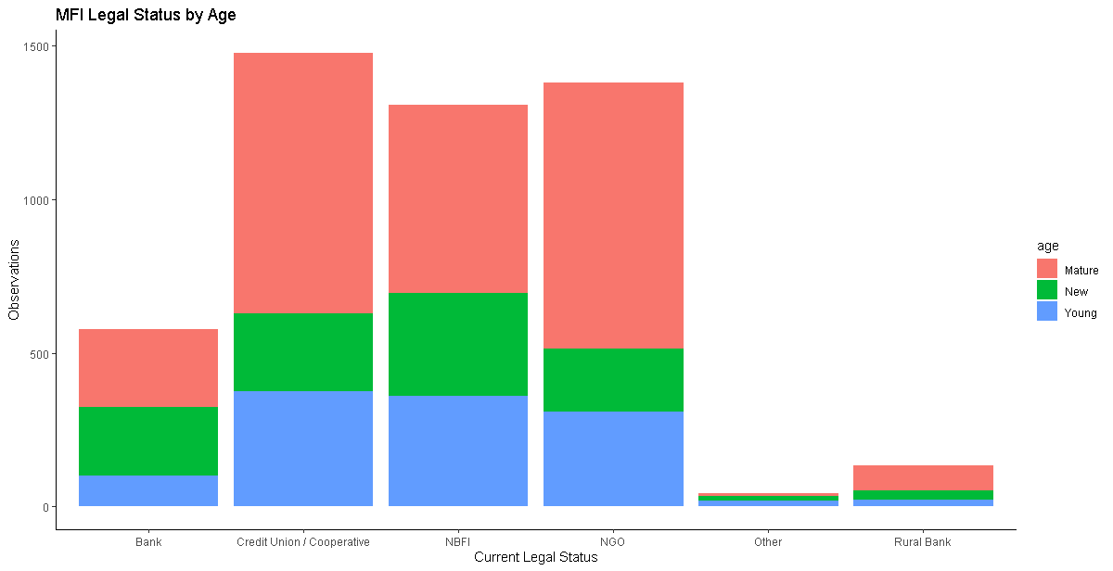

Figure 1: Africa’s MFIs Legal Status by Age Source: Authors’ Construction

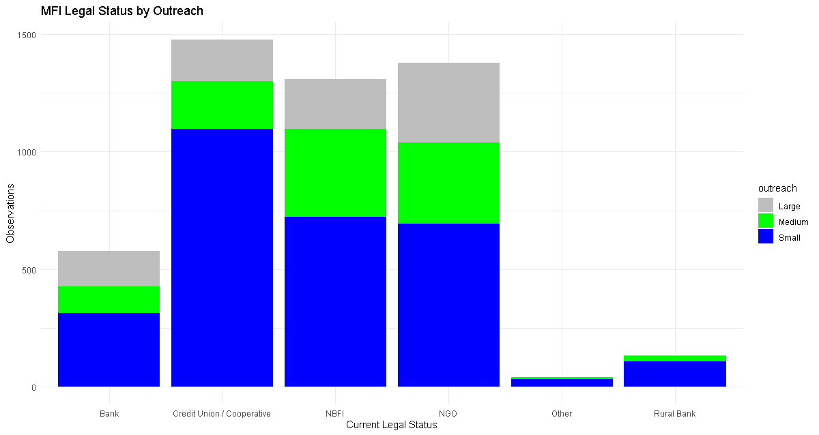

Figure 2: Africa’s MFIs Legal Status by Outreach Source: Authors’ Construction

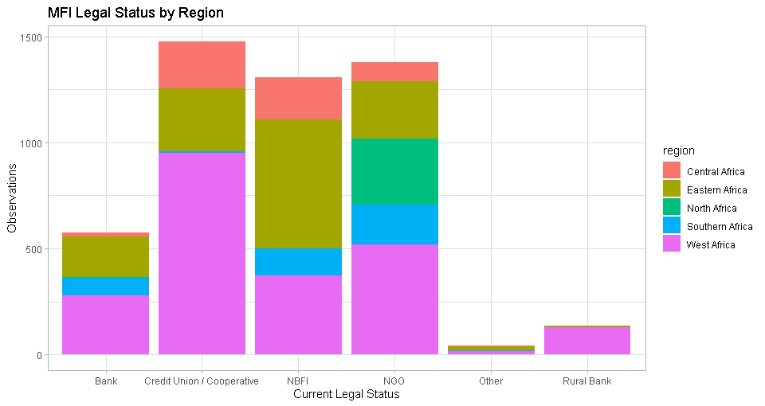Figure 3: Africa’s MFIs Legal Status by Age Source: Authors’ Construction

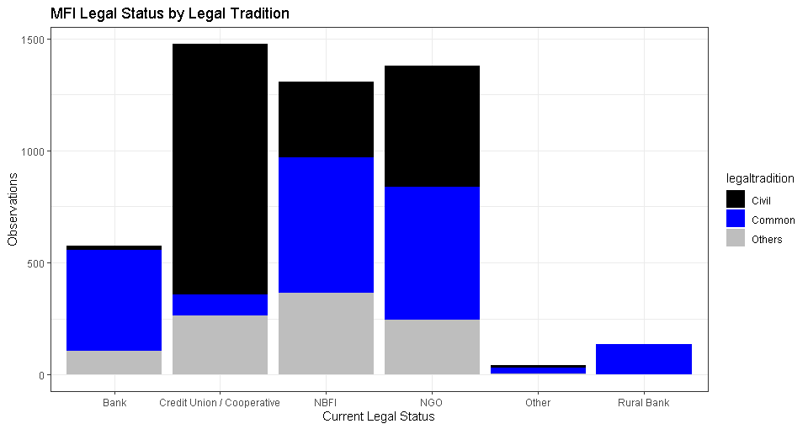

Figure 4: Africa’s MFIs Legal Status by Age Source: Authors’ Construction

**Table 2: Descriptive Statistics and Correlation Matrix**

|  |  |  |  |  |  |  |  |  |  |  |  |  |  |  |  |  |
| --- | --- | --- | --- | --- | --- | --- | --- | --- | --- | --- | --- | --- | --- | --- | --- | --- |
| Variables | | | Obs | | Mean | Std. Dev. | Min | Max | (1) | (2) | (3) | (4) | (5) | (6) | (7) | (8) |
| 1. Current legal Status | | | 4,918 | | 0.72 | 0.45 | 0 | 1 | - |
| (1) Age | | | 4,918 | | 1.70 | 0.83 | 1 | 3 | 1.00 |
| (2) Region | | | 4,918 | | 3.50 | 1.55 | 1 | 5 | 0.00 | 1.00 |
| (3) Size (lassets) | | | 4,738 | | 14.88 | 2.26 | 0.14 | 22.98 | -0.32 | -0.14 | 1.00 |
| (4) GDP Growth | | | 4,918 | | 5.30 | 3.85 | -52.43 | 33.63 | 0.03 | -0.03 | -0.04 | 1.00 |
| (5) Institutional Quality (dkkm) | | | 3,788 | | -0.02 | 0.19 | -0.93 | 1.04 | -0.02 | -0.00 | 0.02 | 0.04 | 1.00 |
| (6) Education (deduc) | | | 3,786 | | 0.01 | 0.03 | -0.30 | 0.27 | -0.05 | 0.02 | 0.00 | 0.01 | -0.03 | 1.00 |
| (7) Financial Development (fd_no_mfi) | | | 4,918 | | -0.09 | 0.73 | -0.41 | 7.94 | 0.01 | -0.14 | 0.03 | -0.05 | -0.03 | 0.04 | 1.00 |
| (8) Legal Tradition | | | 4918 | | 1.79 | 0.75 | 1 | 3 | 0.09 | -0.41 | 0.01 | 0.22 | -0.04 | -0.02 | 0.07 | 1.00 |
|  |  |  | |  |  |  | | | | | | | | | | |
| **Notes:**   1. There is a high correlation between; 2. Size of MFI and age- with the older MFIs having more assets than the relatively young ones. 3. Legal tradition and region are correlated, with legal traditions clustered in regions. For instance, most of Eastern and Southern Africa follows common law with some exceptions of, among others, Madagascar, Mozambique, Ethiopia, and Rwanda. Likewise, West Africa is predominantly of civil law tradition- with notable exceptions like Nigeria, and Ghana. 4. We run a pooled logit/probit. The resultant variance inflation factors mean that multi-collinearity is not a significant problem. 5. We also run regressions that exclude size and legal tradition where both age and region are still significant. 6. Another solution to multi-collinearity is to have a large sample size. Some researchers suggest a ratio of 50 to 100 observations per independent variable. In this case, we have a maximum of 3400 observations that exceed the threshold. 7. An extended table of descriptive statistics for the panel dataset is in the appendix (). | | | | | | | | | | | | | | | | |

**Source: Authors’ Construction**

**Table 3: Stationarity Tests for Variables**

|  |  |  |  |  |  |
| --- | --- | --- | --- | --- | --- |
| We ran the Fisher type unit root tests based on the augmented Dickey-Fuller tests of stationarity that can handle instances of missing data points in a panel setting. The variable total assets (for the size of MFI) was not stationary, but the natural logarithm (lassets), was. Further, we transformed education and institutional quality by taking the first difference.  **Hypotheses: HO:** All panels contain unit-roots.  **H1:** At least one panel is stationary. | | | | | |
|  | Size (lassets) | GDP Growth | Institutional  Quality (dkkm) | Education  (deduc) | Financial Development ((fd_no_mfi) |
| Inverse chi-squared P | 2074.3879*** | 3511.7077*** | 2896.9486*** | 3755.3928*** | 2265.7956*** |
| Inverse normal Z | -1.4296* | -24.1974*** | -26.3351*** | -35.2380*** | -8.1455*** |
| Inverse logit L* | -14.0485*** | -42.9106*** | -40.6264*** | -56.2766*** | -18.9831*** |
| Modified inv. chi-squared Pm | 17.6817**** | 44.7045*** | 47.1681*** | 67.4244*** | 19.9246*** |
| 1. The AR parameter for the test is panel specific. Additionally, we include panel means and a time trend but no drift term. 2. The other variables absent in the unit root test are dummies- current legal status, age, region, and legal tradition. | | | | | |

**Source:** Authors’ constructions from the data

**6.2 Results of the Regression Model**

Given that the study utilises unbalanced panel data, we analyse the entire dataset (the full model), then analyse subsets of the data. We present a schedule of average marginal effects at representative values (MER) for legal tradition, region, and age, respectively. A discussion of the output and its implications from a theoretical and practical perspective follows. We first look at the model as a whole and then examine the effects of each variable on the probability of transformation of MFIs from NGOs to commercial entities.

**6.2.1 The Full Model**

The results from the logit and probit regressions show that the model significantly explains the transformation of MFIs. In each model, with cooperatives included and without cooperatives, the Wald Chi-Squared is significant at 1% level of significance. The model further suggests that holding all the independent variables at their means, the probability of transformation is over 79%, and is significant. We display the output from the regressions (and marginal effects at mean values) in Appendix 1 and appendix 2, which also show the coefficients of the model. We also generate a schedule of marginal effects at representative values (MER) that are part of the appendices. However, as MER tables are hard to interpret, we present margins plots instead (Williams, 2012). Overall, the results show that the age, size, region, financial development, and legal tradition are significant drivers of the transformation of MFIs with substantial regional variations. Education and GDP growth are not. We next highlight the effects of each variable on the probability of transformation.

### Age

The age of an MFI is inversely related to the probability of transformation, given the negative sign of the regression coefficients in Appendix 1 and Appendix 2. It is newly formed MFIs that are likely to convert to the commercial model than the young ones, and young MFIs are more likely to convert than the mature MFIs from the size of the coefficients.

We postulate that older MFIs, being the pioneers, and hence already are well-acquainted with donors making it easier for them to raise funds through donations. Having started their operations before the neo-liberal tradition took hold, they have created goodwill with donors that enable them to raise funds sustainably. These mature MFIs could also have evolved business models that allow them to be financially sustainable without the need to convert to the commercial model by, for example, building a broad customer base in niche markets. Besides, they may have embedded the emphasis on the social mission in their vision, mission, and organisational cultures to such an extent that both the MFI and the donor community find it hard to pull back (Berbegal-Mirabent, Mas-Machuca, & Guix, 2019). It would appear then that MFIs established when the welfare approach was prevalent continue that line.

Younger MFIs, on the other hand, cropped up when the paradigm shift to the institutional approach was taking shape. It means, therefore, that donors were reluctant to extend funds to such organisations. Hence, the MFIs had to supplement the little donor funding and government subsidies by raising funds from the capital markets. The thinking is consistent with the literature that shows the extent to which donor funding is volatile, and especially sensitive to geopolitical realignments (Garmaise & Natividad, 2013; D’Espallier, Hudon, et al., 2017) and business cycles (Wagner & Winkler, 2013).

However, the effects of age on the probability of conversion from an NGO to a commercial model is not uniform. Figure 2 below shows the average marginal effects at representative values (MER). The figure shows that in West Africa, the probability of MFIs converting is lower than in all other regions, including Eastern Africa, the reference dummy. In West Africa, mature firms are, on average, far less likely to transform than younger ones as compared to Eastern Africa and other regions. In central and Southern Africa, the probability of MFIs transforming varies marginally with age compared to Eastern Africa. West Africa appears particularly puzzling.

However, that is not the only peculiarity. Mature MFIs in countries with a relatively more developed financial sector are more likely to convert compared to young and new MFIs. Mature MFIs have more assets to pledge as collateral (Matias & Serrasqueiro, 2017), more extended financial history to allow for credit screening (Vercammen, 1995) and probably more developed corporate governance mechanisms (Qian & Yeung, 2015) that would enable them to attract funds from capital markets. Thus, mature MFIs located in countries with well-developed financial sectors would find it particularly easy to access commercial funding.

On average, MFIs in civil law countries and in other legal traditions (that is, not common law or civil law) are more likely to transform than in common law countries, the reference dummy. However, even in this case, mature firms are more likely to transform than the relatively young, probably due to the reasons articulated earlier. Perhaps it is worth examining whether the flow of donor funding to support MFIs is biased against countries that are outside of the influence of the wealthy and dominant former colonial powers like Britain and France and current economic powers that subscribe to either civil or common law traditions.

All else being constant, mature MFIs with more assets are more likely to transform than the relatively younger MFIs with fewer assets. Perhaps large, mature MFIs can sustain their operations independent of donations and subsidies (D’Espallier et al., 2013). Also, they have a higher capacity to attract money from the capital markets, given their long track record. Lastly, mature MFIs operating in countries with weak governance (institutional quality) are less likely to transform than the relatively young MFIs. The puzzle could be due to issues of private property rights that are harder to enforce in countries with weak governance and the place of governance in the development of capital markets from where such MFIs would draw capital (Johnson, McMillan, & Woodruff, 2002; Claessens & Laeven, 2003). The results are consistent with output from the analysis of data without cooperatives, as shown in appendix 2, which shows the schedule of regression coefficients.

### Size

The size of an MFI, as proxied by the logarithm of assets varies positively with the probability of transformation as coefficients in Appendix 1 and Appendix 2 show. Bigger MFIs are likely to be mature with a track record of decent performance and hence able to attract private capital than their smaller, lesser-known peers. Indeed capital structure theory does show that size, and asset structure of a firm has a bearing on the capital structure (Barclay & Smith, 2005; Barclay, Smith, & Morellec, 2006).

A closer examination shows that the effects are not so clear cut. Figure 3 shows that except for West Africa, where the size of an organisation does not affect the probability of transformation, all the other variables exhibit a similar pattern. In Southern Africa, the probability of an MFI transforming reduces with an increase in the size of an MFI to a point where the probability starts rising with an increase in size. Central Africa also displays a similar pattern though to a lesser extent.

The probability of an MFI transforming rises with the size of an MFI in civil law and other legal traditions compared to common law countries up to a point where the probability starts dropping with an increase in size. Also, as the size of an MFI goes up, financial development raises the probability of transformation. However, when a firm reaches a given size (roughly mid-size), the probabilities of transforming start falling with an increase in size. Overall, it appears that given a level of financial development, mid-sized firms exhibit a higher likelihood of transformation as the trend for size also indicates.

The probability of transformation for Central and Southern Africa, and that for governance index (Institutional quality) are a mirror image of the immediate scenario described above. For the regions, the probability of transforming keeps falling with the size of an MFI to a point where the chances of converting start rising. The probability of transformation for smaller to medium firms is less dependent on governance that it is for large firms. Overall, the results show that many factors are at play jointly in determining whether an MFI transforms or not.

Figure 5: Average marginal Effects at Representative (MER) values of Age (new, young, and mature MFIs ) for the Logit Model

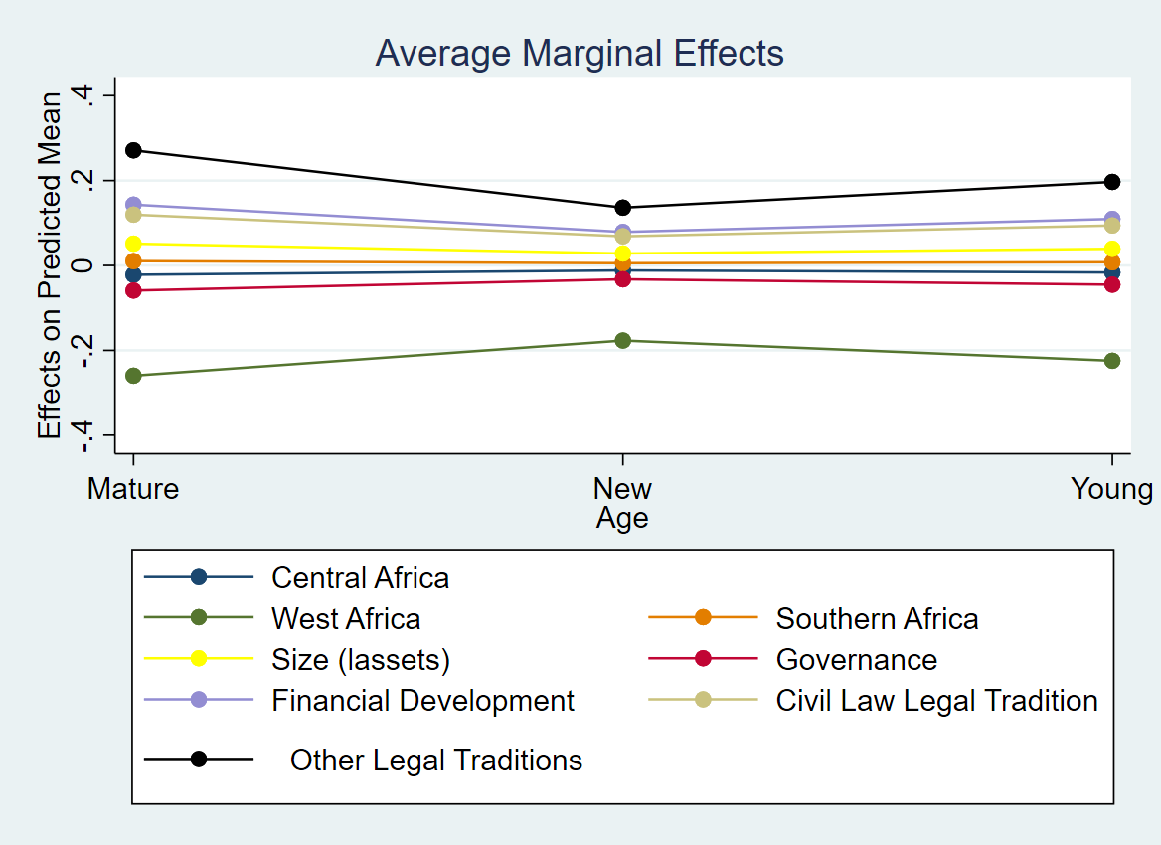

Source: Authors’ Construction

### Region

Overall, MFIs outside of the East African Region are less likely to convert to the commercial model than in Central Africa and Southern Africa. The pattern is probably highlighting the regional colonial heritage and legal traditions that researchers indicate drive financial development (La Porta, Lopez-de-Silanes, & Shleifer, 2013; Oto-Peralías & Romero-Ávila, 2014). Southern Africa predominantly composes of countries following the common law tradition or other legal traditions (like Mozambique and Angola) where the probabilities of transforming are markedly higher than in civil law countries. Tellingly, MFIs in countries with other legal traditions have a higher likelihood of changing. For West Africa, the chances of MFIs converting are positive but insignificant. North Africa has only NGOs listed in the MIX pooled database.

Figure 4 shows the importance of other factors that influence the conversion of MFIs per region. Generally, legal tradition raises the probability that an MFI will transform to the commercial model. Legal tradition raises the probability of an MFI transforming in Southern Africa more than in any other region. Similarly, capital market development is more important in Southern Africa compared to other regions in MFI transformation. The size of an MFI does not appear a significantly important differentiator of MFI transformation across regions, although it is positively related to the probability of transformation overall.

### Capital Market Development/ Financial Development

Financial development is positively related to the probability of MFis transforming from NGOs to commercial entities. For an MFI to transform, the presence of active capital markets enhances the capacity for the acquisition of capital. The arguments here are in line with financial development- economic growth nexus literature (Breitenlechner, Gächter, & Sindermann, 2015; Soedarmono, Hasan, & Arsyad, 2017). As financial development goes up, the probability of MFIs transforming goes down for civil law and other legal traditions.

At low levels of financial development, it is MFIs in civil law and other legal traditions that are more likely to convert (Figure 5). However, the influence of legal tradition drops as financial development increases. Again, the size of an MFI also raises the probability of transformation, but its influence declines with the rise in financial development. MFIs in Southern African countries with low levels of financial development are also less likely to transform than those in Eastern Africa. However, as financial development rises, the probability of transformation rises in Southern Africa but remains flat in West Africa. Although governance is negatively related to the probability of MFIs transforming, its importance rises with increasing financial development. Overall, as financial development rises, the influence of legal tradition, age, size, governance, and regional effects converges such that they have little influence on the probability of transformation. It appears that these factors are only significant in jurisdictions with low levels of financial development.

Figure 6: Average Marginal Effects at Representative (MER) Values for Size of MFIs

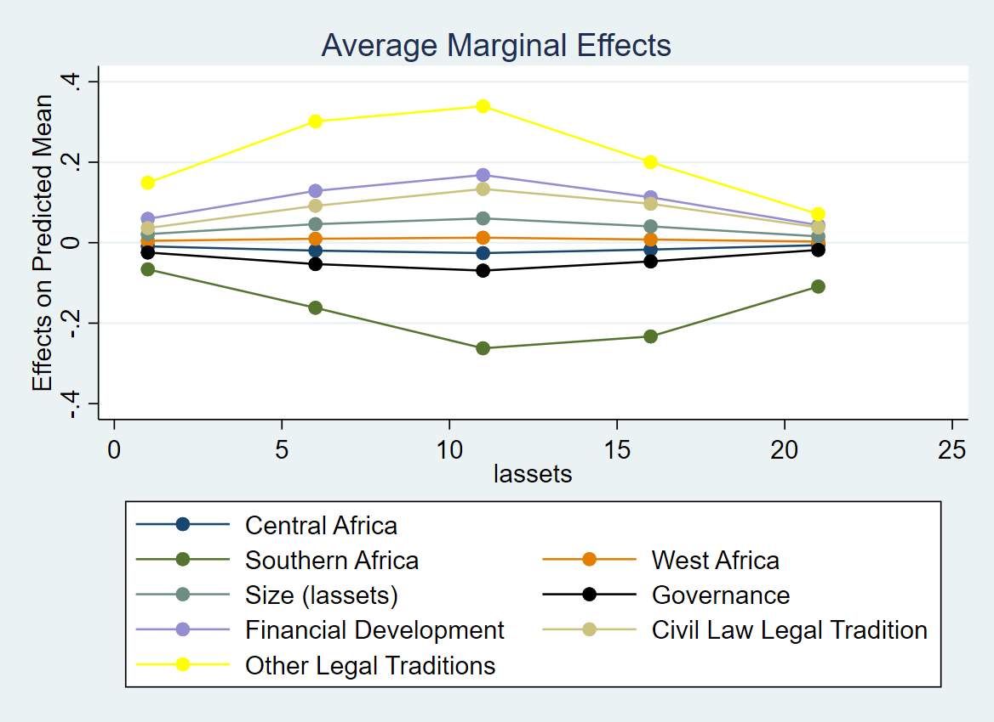

Source: Authors’ Construction

### Institutional Quality

Governance (KKM Index) negatively relates to the odds of transforming. The results probably hold due to the importance of property rights in raising confidence among private investors who finance the operations of transformed MFIs (Allen et al., 2013, 2014). Where governance, and hence property rights are weak, then most MFIs would likely remain NGOs for longer as investors are reluctant to finance private ventures in line with Johnson et al. (2002) and Claessens and Laeven (2003).

As would be expected, better governance/ institutional quality raise the chances of MFIs transforming in West Africa, but not for Central and Southern Africa. While Central Africa appears not sensitive to changes in governance, for Southern Africa, the effects are adverse, which is puzzling. For all the other variables, size, financial development and legal tradition, better governance raise the probability that they will positively influence the transformation of MFIs. The results are in Figure 5.

### Legal Tradition

The legal tradition has an inverse relationship with the probability of transformation, again cementing the place of the law in financial sector development (La Porta et al., 2013). Specifically, MFIs in common law countries are less likely to transform than those in civil law or other legal traditions. MFIs in countries with other legal traditions n have the highest probability of transforming.

As Figure 7 shows, in common law countries; however, the level of financial development and the size of an MFI are more prominent determinants of the transformation than for civil law and other legal traditions. The results could hold due to the higher emphasis on capital market development in common law countries which reflects in the relative ease of acquiring capital from these countries. On the other hand, governance carries less weight in the probability of MFIs transforming in common law countries in comparison with other legal traditions.

Regionally, MFIs in Southern Africa countries that follow the common law tradition are less likely to transform than in other legal traditions. In West Africa, the opposite is the case. For Central Africa, no countries follow the common law tradition, but those following the civil law and the other legal traditions seem equally likely to convert.

Figure 7: Average Marginal Effects at Representative (MER) Values for Regions of MFIs

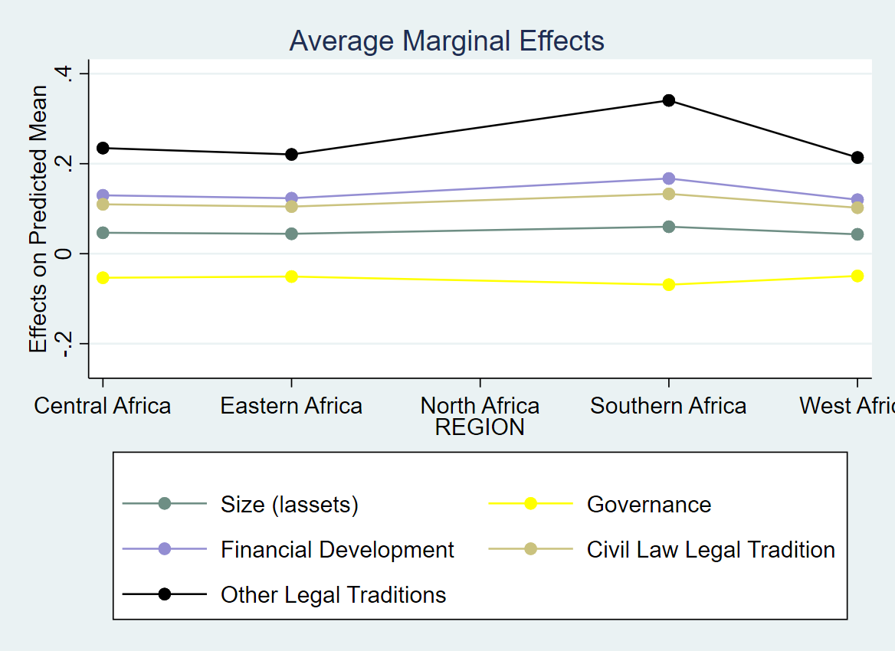

Source: Authors’ Construction

Figure 8: Average Marginal Effects at Representative (MER) Values for Country-Level Financial Development

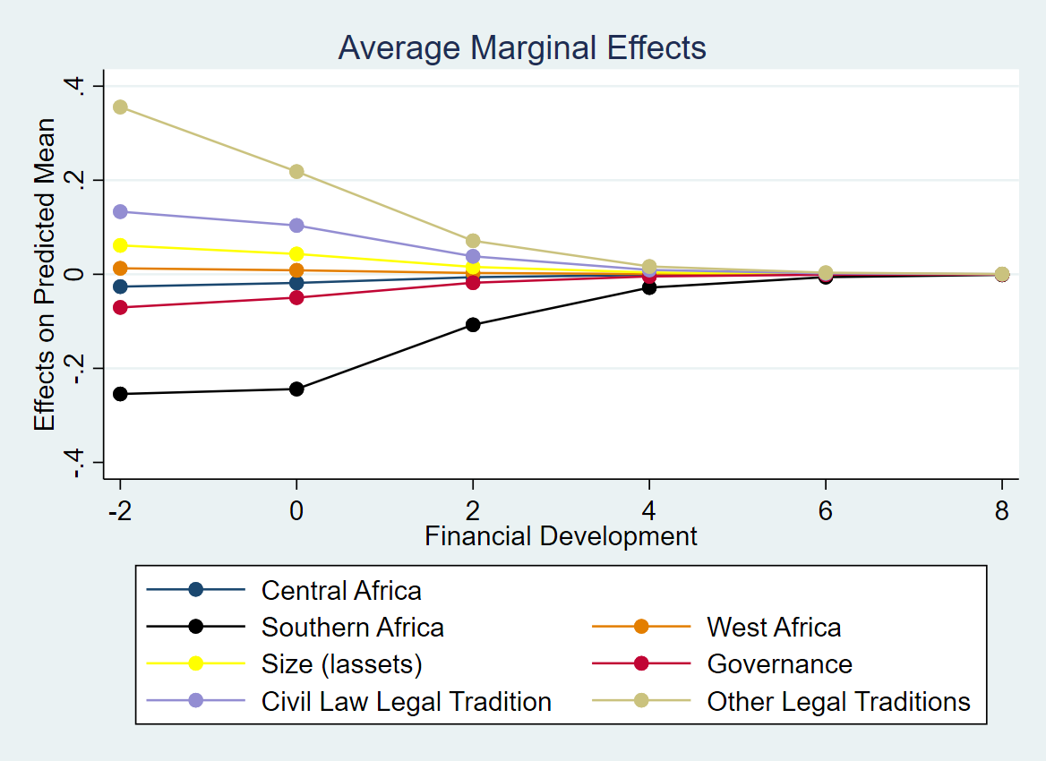

Source: Authors’ Construction

Figure 9: Average Marginal Effects at Representative (MER) Values for Governance/ Institutional Quality

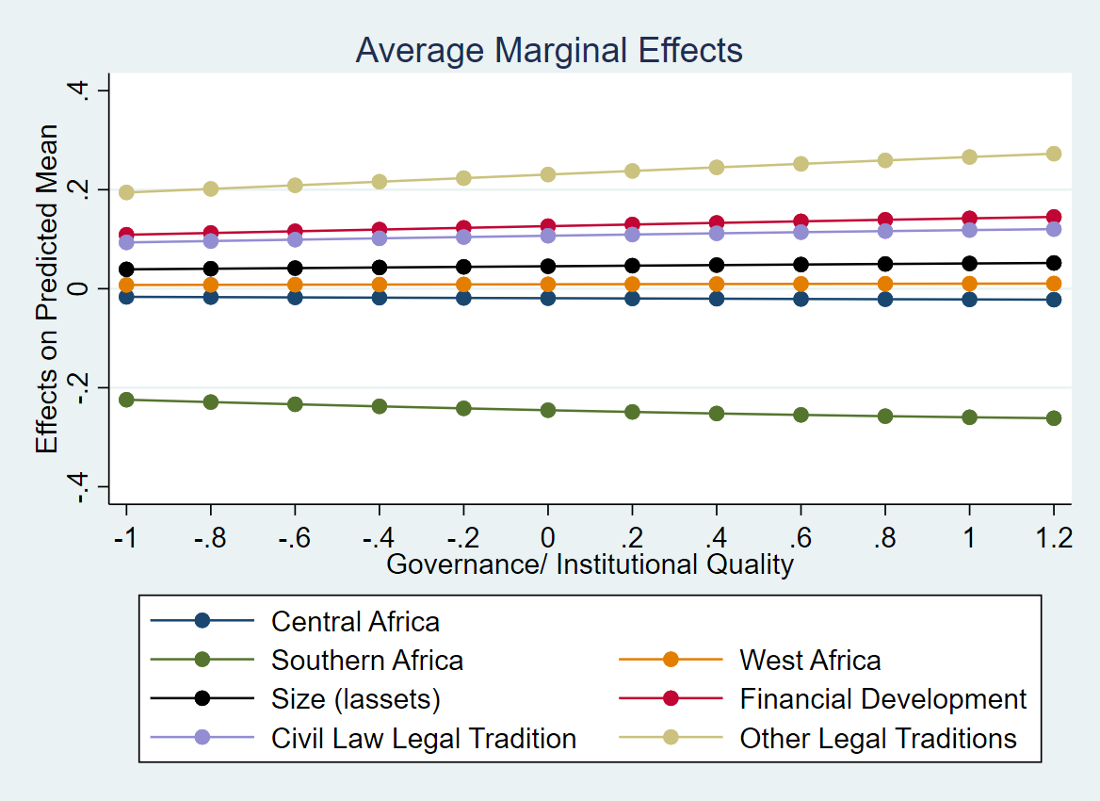

Source: Authors’ Construction

Figure 10: Average Marginal Effects at Representative (MER) Values for Legal Tradition

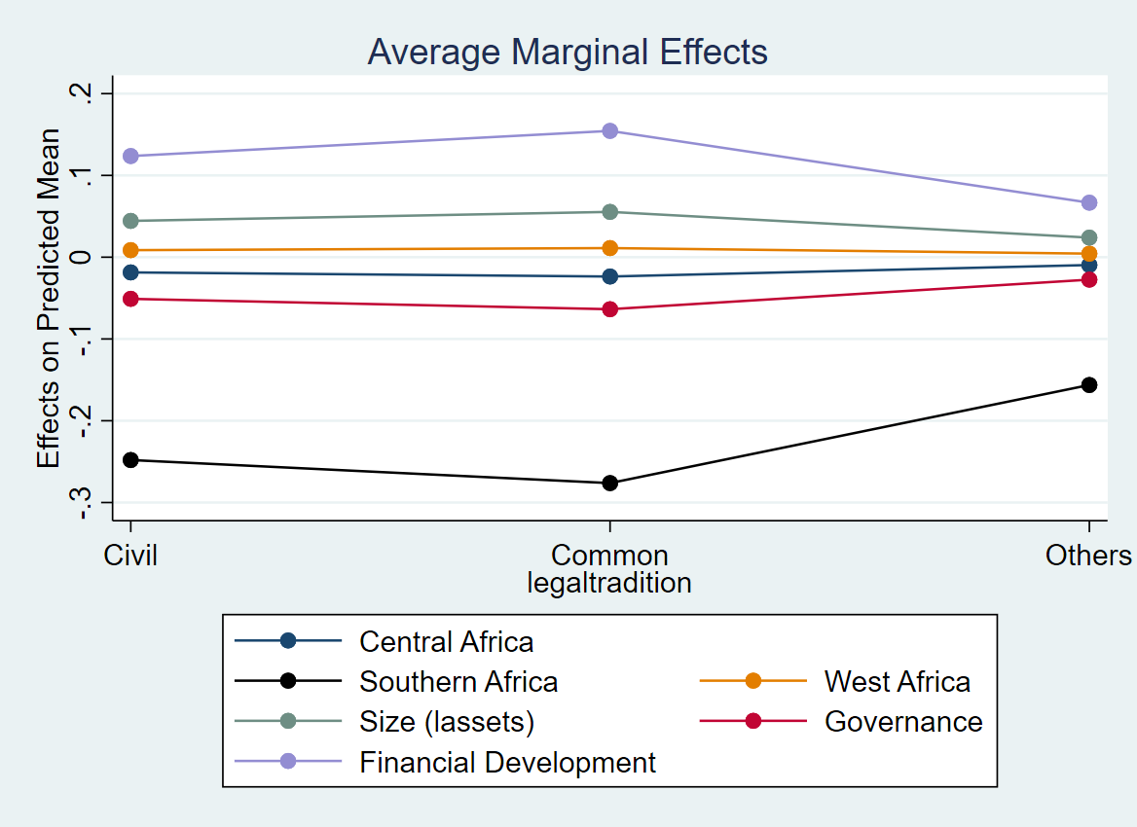

Source: Authors’ Construction

## Robustness Checks

We run several robustness checks for our study. First, we run the analysis for the full dataset both with credit unions/ cooperatives included and without the credit unions. The results did not change much, and the inference remained as it was. Furthermore, because we utilised unbalanced panel data, we run the model for a varying number of years. For instance, we run the analysis for MFIs with at least five years of data, and at most seven years of data. The inference from the different years of analysis was stable. We also winsorized the data, taking out the top 10% and the bottom 10% of the observations and rerun the model finding no significant differences in the inference. Finally, we run logit and probit models using pooled data and, again, find results consistent with the models using panel data.

## Conclusion

This article examined the factors that make MFIs in Africa to convert from NGOs to the commercial model. We find that legal tradition, age, size, financial development, and governance are significant with regional variations. Although these factors influence the probability of transformation, the interactions between these factors are also meaningful. For instance, although size of an MFI raises the probability of transformation, it is more critical in countries with low levels of financial development. Likewise. Financial development raises the probability of transformation but is more critical for medium-sized firms opposed to large and small firms. Legal tradition raises the probability of transformation but is more prominent in common law countries. The heterogeneity uncovered highlights the danger of working with global or regional pooled datasets without considering regional / variables variation. Policy-makers desiring for more sustainable MFIs can only target what they can control. In this case, developing financial systems/ capital markets appears especially essential if such firms are to access finance easily.

**REFERENCES**

Abdulai, A., & Tewari, D. D. (2017). Trade-off between outreach and sustainability of microfinance institutions: evidence from Sub-Saharan Africa. *Enterprise Development and Microfinance, 28*(3), 162-181.

Allen, F., Carletti, E., Cull, R., Qian, J. Q., Senbet, L., & Valenzuela, P. (2013). *Resolving the African financial development gap: Cross-country comparisons and a within-country study of Kenya*. New York: The World Bank.

Allen, F., Carletti, E., Cull, R., Qian, J. Q., Senbet, L., & Valenzuela, P. (2014). The African financial development and financial inclusion gaps. *Journal of African Economies, 23*(5), 614-642.

Awaworyi Churchill, S. (2018). Sustainability and depth of outreach: Evidence from microfinance institutions in sub‐Saharan Africa. *Development Policy Review, 36*, O676-O695.

Baltagi, B. H., Demetriades, P. O., & Law, S. H. (2009). Financial development and openness: Evidence from panel data. *Journal of Development Economics, 89*(2), 285-296.

Barclay, M. J., & Smith, C. W. (2005). The capital structure puzzle: The evidence revisited. *Journal of Applied Corporate Finance, 17*(1), 8-17.

Barclay, M. J., Smith, J., Clifford W, & Morellec, E. (2006). On the debt capacity of growth options. *The Journal of Business, 79*(1), 37-60.

Bateman, M. (2010). *Why doesn't microfinance work?: The destructive rise of local neoliberalism*. London: Zed Books Ltd.

Bayai, I., & Ikhide, S. (2016). Financing and financial sustainability of microfinance institutions (MFIs): A conceptual view. *Banks and Bank Systems, 2*(2), 21-32.

Berbegal-Mirabent, J., Mas-Machuca, M., & Guix, P. (2019). Impact of mission statement components on social enterprises’ performance. *Review of Managerial Science*, 1-20.

Breitenlechner, M., Gächter, M., & Sindermann, F. (2015). The finance–growth nexus in crisis. *Economics Letters, 132*, 31-33.

Campion, A., & White, V. (1999). *Institutional metamorphosis: Transformation of microfinance NGOs into regulated financial institutions*. New York: MicroFinance Network.

Chahine, S., & Tannir, L. (2010). On the social and financial effects of the transformation of microfinance NGOs. *Voluntas: International Journal of Voluntary and Nonprofit Organizations, 21*(3), 440-461.

Christen, R. P., & Cook, T. (2001). *Commercialization and mission drift: The transformation of microfinance in Latin America*. New York: Consultative Group to Assist the Poorest (CGAP).

Claessens, S., & Laeven, L. (2003). Financial development, property rights, and growth. *The Journal of Finance, 58*(6), 2401-2436.

Creedy, J., & Hoang, H. T. (2018). Types of microfinance organisation: A taxonomy. *Third Sector Review, 24*(2), 105.

D’Espallier, B., Goedecke, J., Hudon, M., & Mersland, R. (2017). From NGOs to banks: Does institutional transformation alter the business model of microfinance institutions? *World Development, 89*, 19-33.

D’Espallier, B., Hudon, M., & Szafarz, A. (2013). Unsubsidized microfinance institutions. *Economics Letters, 120*(2), 174-176.

D’Espallier, B., Hudon, M., & Szafarz, A. (2017). Aid volatility and social performance in microfinance. *Nonprofit and Voluntary Sector Quarterly, 46*(1), 116-140.

Demirguc-Kunt, A., Klapper, L., Singer, D., Ansar, S., & Hess, J. (2018). *The Global Findex Database 2017: Measuring Financial Inclusion and the Fintech Revolution*. New York: The World Bank.

DiMaggio, P., & Powell, W. (1991). Introduction. In *The new institutionalism and organizational analysis* (pp. 1-38). Chicago: University of Chicago Press.

Fernando, N. A. (2004). *Micro success story?: transformation of nongovernment organizations into regulated financial institutions*. Mandaluyong, The Philippines: Asian Development Bank.

Forkusam, A. N. (2014). Does financial globalization affect microfinance mission drift? In R. Mersland & R. Ø. Strøm (Eds.), *Microfinance institutions: Financial and social performance* (pp. 79-98). London: Palgrave Macmillan UK.

Garmaise, M. J., & Natividad, G. (2013). Cheap credit, lending operations, and international politics: The case of global microfinance. *The Journal of Finance, 68*(4), 1551-1576.

Gutiérrez-Nieto, B., & Serrano-Cinca, C. (2019). 20 years of research in microfinance: An information management approach. *International Journal of Information Management, 47*, 183-197.

Gwatidzo, T., & Ojah, K. (2009). Corporate capital structure determinants: evidence for five African countries. *African Finance Journal, 11*(1), 1-23.

Hishigsuren, G. (2006). Transformation of Micro-finance Operations from NGO to Regulated MFI. *IDEAS, USA, 2*(1), 15-31.

Ito, H., & Kawai, M. (2018). Quantity and Quality Measures of Financial Development: Implications for Macroeconomic Performance. *Public Policy Review, 14*(5), 803-834.

Jarotschkin, A. (2013). Microfinance in Africa. In T. Beck & S. Munzele (Eds.), *Financial Sector Development in Africa* (pp. 7-40). New York: The World bank.

Jia, X., Cull, R., Guo, P., & Ma, T. (2016). Commercialization and mission drift: Evidence from a large Chinese microfinance institution. *China Economic Review, 40*, 17-32.

Johnson, S., McMillan, J., & Woodruff, C. (2002). Property rights and finance. *American Economic Review, 92*(5), 1335-1356.

Klapper, L., & Singer, D. (2014). The role of informal financial services in Africa. *Journal of African Economies, 24*(suppl_1), i12-i31.

Kodongo, O., & Kendi, L. G. (2013). Individual lending versus group lending: An evaluation with Kenya's microfinance data. *Review of Development Finance, 3*(2), 99-108.

Kota, I. (2007). Microfinance: Banking for the poor. *Finance and Development, 44*(2), 44.

La Porta, R., Lopez-de-Silanes, F., & Shleifer, A. (2013). Law and finance after a decade of research. In G. M. Constantinides, M. Harris, & R. M. Stulz (Eds.), *Handbook of the Economics of Finance* (Vol. 2A, pp. 426-470). Amsterdam: North Holland.

Ledgerwood, J., & White, V. (2006). *Transforming microfinance institutions: providing full financial services to the poor*. New York: World Bank Publications.

Mader, P. (2015). The financialization of poverty. In *The Political Economy of Microfinance* (pp. 78-120): Springer.

Martínez-Ferrero, J., & García-Sánchez, I.-M. (2017). Coercive, normative and mimetic isomorphism as determinants of the voluntary assurance of sustainability reports. *International Business Review, 26*(1), 102-118.

Matias, F., & Serrasqueiro, Z. (2017). Are there reliable determinant factors of capital structure decisions? Empirical study of SMEs in different regions of Portugal. *Research in International Business and Finance, 40*, 19-33.

Mersland, R., & Strøm, R. Ø. (2010). Microfinance mission drift? *World Development, 38*, 28-36.

Mia, M. A., & Lee, H.-A. (2017). Mission drift and ethical crisis in microfinance institutions: What matters? *Journal of Cleaner Production, 164*, 102-114.

Microfinance Information Exchange (MIX). (2019). *Global Outreach & Financial Performance Benchmark Report - 2017-2018*. Retrieved from New York: <https://www.themix.org/sites/default/files/mix_market_global_outreach_financial_benchmark_report_2017-2018.pdf>

Morduch, J. (1999). The microfinance promise. *Journal of Economic Literature, 37*(4), 1569-1614.

Morduch, J. (2000). The microfinance schism. *World Development, 28*(4), 617-629.

Nason, R. S., Bacq, S., & Gras, D. (2018). A Behavioral Theory of Social Performance: Social Identity and Stakeholder Expectations. *Academy of Management Review, 43*(2), 259-283.

Nurmakhanova, M., Kretzschmar, G., & Fedhila, H. (2015). Trade-off between financial sustainability and outreach of microfinance institutions. *Eurasian Economic Review, 5*(2), 231-250.

O’Malley, T., & Burke, J. (2017). A systematic review of microfinance and women’s health literature: Directions for future research. *Global Public Health, 12*(11), 1433-1460.

Ojah, K., & Ombati, S. (2016). Effects of financing and institutional constraints on capital structure of firms in select African countries. *African Finance Journal, 18*(2), 1-44.

Ostry, J., Loungani, P., & Furceri, D. (2017). Neoliberalism: Oversold? *Finance and Development, 2*(2017), 38-41.

Oto-Peralías, D., & Romero-Ávila, D. (2014). The distribution of legal traditions around the world: a contribution to the legal-origins theory. *The Journal of Law and Economics, 57*(3), 561-628.

Pashkova, N., Trujillo-Barrera, A., Apostolakis, G., Van Dijk, G., Drakos, P., & Baourakis, G. (2016). Business management models of microfinance institutions (MFIs) in Africa: A study into their enabling environments. *International Journal of Food and Beverage Manufacturing and Business Models 2*(2), 63-82.

Qian, M., & Yeung, B. Y. (2015). Bank financing and corporate governance. *Journal of Corporate Finance, 32*, 258-270.

Rajan, R., & Zingales, L. (1998). Financial development and growth. *American Economic Review, 88*(3), 559-586.

Ramus, T., & Vaccaro, A. (2017). Stakeholders matter: How social enterprises address mission drift. *Journal of Business Ethics, 143*(2), 307-322. doi:10.1007/s10551-014-2353-y

Scott, W. (2004). Institutional theory. In *Encyclopaedia of social theory* (pp. 408-414). Thousand Oaks, CA.: Sage.

Shahriar, A. Z. M., & Garg, M. (2017). Lender–entrepreneur relationships and credit risk: A global analysis of microfinance institutions. *International Small Business Journal, 35*(7), 829-854.

Silva, P. (2018). Neoliberalism, democratization, and the rise of technocrats. In *The Changing Role of the State in Latin America* (pp. 75-92): Routledge.

Soedarmono, W., Hasan, I., & Arsyad, N. (2017). Non-linearity in the finance-growth nexus: Evidence from Indonesia. *International Economics, 150*, 19-35.

Vercammen, J. A. (1995). Credit bureau policy and sustainable reputation effects in credit markets. *Economica, 62*, 461-478.

Wagner, C., & Winkler, A. (2013). The vulnerability of microfinance to financial turmoil–evidence from the global financial crisis. *World Development, 51*, 71-90.

Wang, K., & Shailer, G. (2015). Ownership concentration and firm performance in emerging markets: a meta‐analysis. *Journal of Economic Surveys, 29*(2), 199-229.

Williams, R. (2012). Using the margins command to estimate and interpret adjusted predictions and marginal effects. *The Stata Journal, 12*(2), 308-331.

Zaby, S. (2019). Science Mapping of the Global Knowledge Base on Microfinance: Influential Authors and Documents, 1989–2019. *Sustainability, 11*(14), 3883.

## Appendices

### Appendix 1: Summary Statistics for Panel dataset (Extended)

|  |  |  |  |  |  |  |
| --- | --- | --- | --- | --- | --- | --- |
| **Variable** |  | **Mean** | **Std. Dev.** | **Min** | **Max** | **Observations** |
|  |  |  |  |  |  |  |
| Current Legal | overall | 0.7198 | 0.4491 | 0 | 1 | N = 4918 |
| Status (Dummy) | between |  | 0.4080 | 0 | 1 | n = 911 |
|  | within |  | 0.0130 | -0.1135 | 0.8865 | T-bar = 5.3985 |
|  |  |  |  |  |  |  |
| Age (Dummy) | overall | 1.6987 | 0.8327 | 1 | 3 | N = 4918 |
|  | between |  | 0.6703 | 1 | 3 | n = 911 |
|  | within |  | 0.5743 | 0.0987 | 3.5934 | T-bar = 5.3985 |
|  |  |  |  |  |  |  |
| Region (Dummy) | overall | 3.5043 | 1.5450 | 1 | 5 | N = 4918 |
|  | between |  | 1.5677 | 1 | 5 | n = 911 |
|  | within |  | 0 | 3.5043 | 3.5043 | T-bar = 5.3985 |
|  |  |  |  |  |  |  |
| Size (lassets) | overall | 14.8748 | 2.2571 | 0.1398 | 22.9786 | N = 4738 |
|  | between |  | 2.2082 | 3.0067 | 22.6132 | n = 841 |
|  | within |  | 0.8051 | 9.5202 | 19.3762 | T-bar = 5.6338 |
|  |  |  |  |  |  |  |
| GDP Growth | overall | 5.3030 | 3.8446 | -52.4275 | 33.6294 | N = 4918 |
|  | between |  | 2.3382 | -12.9446 | 14.0471 | n = 911 |
|  | within |  | 3.2785 | -46.5989 | 41.3544 | T-bar = 5.3985 |
|  |  |  |  |  |  |  |
| Institutional | overall | -0.02013 | 0.1908 | -0.9316 | 1.0440 | N = 3788 |
| Quality dkkm | between |  | 0.1174 | -0.7585 | 0.4112 | n = 778 |
|  | within |  | 0.1732 | -0.8930 | 0.9177 | T-bar = 4.8689 |
|  |  |  |  |  |  |  |
| Education (deduc) | overall | 0.0099 | 0.0328 | -0.2966 | 0.2685 | N = 3786 |
|  | between |  | 0.0192 | -0.1014 | 0.0946 | n = 777 |
|  | within |  | 0.0296 | -0.2830 | 0.2821 | T-bar = 4.8726 |
|  |  |  |  |  |  |  |
| Financial | overall | -0.09070 | 0.7303 | -0.4081 | 7.9411 | N = 4918 |
| development | between |  | 0.8393 | -0.4081 | 7.9411 | n = 911 |
| (fd_no_mfi) | within |  | 0.1315 | -1.4043 | 1.1936 | T-bar = 5.3985 |
|  |  |  |  |  |  |  |
| Legal Tradition | overall | 1.7869 | 0.7539 | 1 | 3 | N = 4918 |
|  | between |  | 0.7326 | 1 | 3 | n = 911 |
|  | within |  | 0 | 1.7869 | 1.7869 | T-bar = 5.3985 |

### Appendix 2: Mixed Logit / Probit Regressions with Cooperatives

|  |
| --- |
| Table 1.1: Transformation of Microfinance in Africa (Mixed Effects with Cooperatives) |
| |  |  |  |  |  |  |  |  |  |  |  | | --- | --- | --- | --- | --- | --- | --- | --- | --- | --- | --- | |  | (1) | (2) | (3) | (4) | (5) | (6) | (7) | (8) | (9) | (10) | | VARIABLES | Logit Full  Data | Probit Full  Data | Logit_  Data<=5 | Probit_  Data<=5 | Logit_  Data>=5 | Probit_  Data>=5 | Logit_  Data>=6 | Probit_  Data>=6 | Logit_  Data<=7 | Probit_  Data<=7 | |  |  |  |  |  |  |  |  |  |  |  | | Age Dummy- Mature (see note 6) | -1.3048*** | -0.7508*** | -0.7439*** | -0.4173*** | -1.1047*** | -0.6463*** | -1.1666*** | -0.6815*** | -0.7010*** | -0.3959*** | |  | (0.1435) | (0.0807) | (0.2811) | (0.1533) | (0.1674) | (0.0962) | (0.1785) | (0.1023) | (0.2201) | (0.1212) | | Age Dummy- Young | -0.6033*** | -0.3486*** | -0.6142** | -0.3571** | -0.2464 | -0.1560 | -0.3480* | -0.2131* | -0.3325 | -0.1937 | |  | (0.1518) | (0.0856) | (0.2835) | (0.1558) | (0.1777) | (0.1018) | (0.1909) | (0.1092) | (0.2176) | (0.1213) | | Central Africa Dummy (See note 7) | -0.1226 | -0.1425 | -0.0485 | -0.0429 | -0.2990 | -0.2508** | -0.3332 | -0.2729** | 0.6126* | 0.2867 | |  | (0.1823) | (0.1023) | (0.5199) | (0.2853) | (0.1985) | (0.1119) | (0.2027) | (0.1148) | (0.3595) | (0.1964) | | Southern Africa Dummy | -1.3179*** | -0.8192*** | -1.9058*** | -1.1253*** | -1.1090*** | -0.6758*** | -1.0715*** | -0.6534*** | -0.8803** | -0.5651*** | |  | (0.1585) | (0.0934) | (0.4374) | (0.2522) | (0.1707) | (0.1019) | (0.1770) | (0.1055) | (0.3422) | (0.2056) | | West Africa Dummy | 0.0593 | 0.0003 | 0.2104 | 0.1336 | -0.1110 | -0.1022 | -0.0806 | -0.0870 | 0.9265*** | 0.5222*** | |  | (0.1244) | (0.0726) | (0.3314) | (0.1868) | (0.1377) | (0.0821) | (0.1421) | (0.0850) | (0.2271) | (0.1309) | | Size | 0.2911*** | 0.1683*** | 0.3581*** | 0.2055*** | 0.3801*** | 0.2240*** | 0.4102*** | 0.2426*** | 0.4039*** | 0.2333*** | |  | (0.0246) | (0.0140) | (0.0581) | (0.0325) | (0.0304) | (0.0175) | (0.0325) | (0.0187) | (0.0474) | (0.0265) | | GDP Growth Annual | 0.0022 | 0.0031 | 0.0690* | 0.0400* | -0.0218 | -0.0144 | -0.0269 | -0.0173* | 0.0541** | 0.0291* | |  | (0.0148) | (0.0083) | (0.0378) | (0.0211) | (0.0162) | (0.0093) | (0.0165) | (0.0096) | (0.0272) | (0.0154) | | Institutional Quality | -0.3342 | -0.1909 | -0.9497* | -0.5479* | -0.0073 | -0.0136 | 0.0430 | 0.0105 | -0.7879* | -0.4412* | |  | (0.2375) | (0.1358) | (0.5657) | (0.3121) | (0.2636) | (0.1510) | (0.2794) | (0.1596) | (0.4309) | (0.2434) | | Education | 0.2611 | 0.3440 | 0.2374 | 0.2837 | -1.1673 | -0.5449 | -0.8186 | -0.3062 | 1.5358 | 0.9472 | |  | (1.4636) | (0.8536) | (3.6976) | (2.0612) | (1.6229) | (0.9502) | (1.7314) | (1.0113) | (2.5788) | (1.4716) | | Financial Development | 0.8113*** | 0.4284*** | 0.2417 | 0.1500* | 1.2130*** | 0.6761*** | 1.3780*** | 0.7581*** | 0.3974*** | 0.2303*** | |  | (0.1072) | (0.0497) | (0.1482) | (0.0839) | (0.1508) | (0.0790) | (0.1691) | (0.0871) | (0.1189) | (0.0661) | | Civil Law Dummy (see note 8) | 0.6187*** | 0.3750*** | 0.4562 | 0.2539 | 0.9024*** | 0.5483*** | 0.8844*** | 0.5398*** | 0.2890 | 0.1655 | |  | (0.1102) | (0.0647) | (0.2892) | (0.1577) | (0.1232) | (0.0733) | (0.1278) | (0.0761) | (0.2113) | (0.1177) | | Others- Legal Tradition Dummy | 1.6793*** | 0.9839*** | 2.5235*** | 1.3048*** | 1.8099*** | 1.0832*** | 1.8667*** | 1.1188*** | 2.4554*** | 1.3008*** | |  | (0.1671) | (0.0944) | (0.6864) | (0.3360) | (0.1793) | (0.1032) | (0.1835) | (0.1061) | (0.4550) | (0.2259) | |  |  |  |  |  |  |  |  |  |  |  | | Constant | -3.1442*** | -1.8164*** | -5.9875*** | -3.4750*** | -4.3799*** | -2.5533*** | -4.8638*** | -2.8594*** | -6.5576*** | -3.7653*** | |  | (1.0079) | (0.6041) | (1.5597) | (0.9191) | (0.5892) | (0.3421) | (0.6264) | (0.3645) | (1.2956) | (0.7600) | |  |  |  |  |  |  |  |  |  |  |  | | Observations | 3,400 | 3,400 | 853 | 853 | 2,762 | 2,762 | 2,544 | 2,544 | 1,353 | 1,353 | | Wald Chi^2 | 379.97*** | 414.95*** | 120.69*** | 134.10*** | 357.49*** | 386.68*** | 347.06*** | 377.81*** | 157.69*** | 171.39*** | | Margins, at means | 0.8038*** | 0.7974*** | 0.8955*** | 0.8891*** | 0.8019*** | 0.7951*** | 0.7993*** | 0.7913*** | 0.8786*** | 0.8729*** |   Standard errors in parentheses |
| At *** p<0.01, ** p<0.05, * p<0.1 significance levels |
| **Notes to the Regressions:**   1. We run logit and probit regressions in the following order. 2. Regressions 1 and 2 used the entire unbalanced panel dataset. 3. Regressions 3 and 4 utilised segmented data for MFIs with at most five (5) of data. 4. Regressions 5 and 6 included only those MFIs with at least five (5) years of data. 5. Regression 7 is for MFIs with six (6) or more years of data where the logit model did not converge to a solution. The logit model also did not converge to a solution for at least seven (7) and at least eight (8) years of data. 6. Regression 8 and 9 are only for MFIs with at most seven (7) years of data. 7. For North Africa, all MFIs included in the MIX pooled database operated as NGOs for the entire period. Hence the dummy predicted a failure to convert with 100% precision and drops from the observations. Thus North Africa does not appear among the regional dummies. 8. We use random effects logit, and probit models as the data lack adequate within-group variance to allow for a comparative fixed-effects model. 9. The margins at means predict the probability of an MFI converting from an NGO to a commercial firm at the average values of the regressors, and taking into account the random effects. We treat Dummies individually, not averages. 10. Margins, pu0 predicts the probability that an MFI converts from an NGO to a commercial venture assuming zero (0) random effects. 11. The reference age is new; that is, MFIs classified by MIX to be between (………….) years old. 12. Eastern Africa is the regional reference dummy. 13. The Common law dummy is the reference point. |

### Appendix 3: Mixed Logit / Probit Regressions without Cooperatives

|  |
| --- |
| Table 1.1: Transformation of Microfinance in Africa (Mixed Logit Without Cooperatives) |
| |  |  |  |  |  |  |  |  |  |  |  | | --- | --- | --- | --- | --- | --- | --- | --- | --- | --- | --- | |  | (1) | (2) | (3) | (4) | (5) | (6) | (7) | (8) | (9) | (10) | | VARIABLES | Logit  Full Data | Probit_  Full Data | Logit_  Data<=5 | Probit_  Data<=5 | Logit_  Data>=5 | Probit_  Data>=5 | Logit_  Data>=6 | Probit_  Data>=6 | Logit_  Data<=7 | Probit_  Data<=7 | |  |  |  |  |  |  |  |  |  |  |  | | Age Dummy- Mature (see note 6) | -1.7872*** | -1.0292*** | -1.2289*** | -0.6853*** | -1.6021*** | -0.9300*** | -1.6142*** | -0.9343*** | -1.1969*** | -0.6871*** | |  | (0.1582) | (0.0897) | (0.3227) | (0.1799) | (0.1851) | (0.1063) | (0.1950) | (0.1117) | (0.2498) | (0.1416) | | Age Dummy- Young | -0.9706*** | -0.5584*** | -0.9306*** | -0.5262*** | -0.6608*** | -0.3863*** | -0.7596*** | -0.4399*** | -0.8461*** | -0.4813*** | |  | (0.1676) | (0.0961) | (0.3302) | (0.1859) | (0.1953) | (0.1132) | (0.2080) | (0.1202) | (0.2517) | (0.1438) | | Central Africa Dummy (See note 7) | 0.3482* | 0.1138 | 0.2265 | 0.0992 | 0.2359 | 0.0579 | 0.1077 | -0.0071 | 0.7414* | 0.3968 | |  | (0.2102) | (0.1184) | (0.6018) | (0.3486) | (0.2263) | (0.1270) | (0.2315) | (0.1308) | (0.4285) | (0.2435) | | Southern Africa Dummy | -1.1528*** | -0.6866*** | -1.8892*** | -1.1131*** | -0.9397*** | -0.5495*** | -0.8952*** | -0.5258*** | -0.7746** | -0.4800** | |  | (0.1612) | (0.0960) | (0.4754) | (0.2745) | (0.1752) | (0.1050) | (0.1804) | (0.1084) | (0.3834) | (0.2259) | | West Africa Dummy | -0.0957 | -0.0700 | -0.0293 | -0.0250 | -0.3028* | -0.1970** | -0.2710* | -0.1774* | 0.6627*** | 0.3826** | |  | (0.1390) | (0.0807) | (0.3643) | (0.2089) | (0.1591) | (0.0930) | (0.1644) | (0.0965) | (0.2569) | (0.1487) | | Size | 0.4392*** | 0.2510*** | 0.4786*** | 0.2775*** | 0.5602*** | 0.3309*** | 0.5767*** | 0.3412*** | 0.5558*** | 0.3242*** | |  | (0.0315) | (0.0174) | (0.0713) | (0.0389) | (0.0394) | (0.0225) | (0.0416) | (0.0238) | (0.0605) | (0.0325) | | GDP Growth Annual | 0.0171 | 0.0120 | 0.0223 | 0.0167 | -0.0016 | -0.0007 | 0.0008 | 0.0006 | 0.0316 | 0.0174 | |  | (0.0169) | (0.0098) | (0.0466) | (0.0259) | (0.0187) | (0.0110) | (0.0189) | (0.0111) | (0.0355) | (0.0195) | | Institutional Quality | -0.4948* | -0.2950* | -1.0446 | -0.6000 | -0.1242 | -0.0738 | -0.0766 | -0.0474 | -0.9635* | -0.5576* | |  | (0.2700) | (0.1572) | (0.6684) | (0.3723) | (0.2973) | (0.1732) | (0.3153) | (0.1834) | (0.5115) | (0.2921) | | Education | 1.6293 | 1.1707 | 2.2523 | 1.4468 | 0.9465 | 0.7322 | 1.4687 | 1.0239 | 4.4952 | 2.8783 | |  | (1.7484) | (1.0269) | (4.6260) | (2.6113) | (1.9481) | (1.1478) | (2.0647) | (1.2061) | (3.3280) | (1.9537) | | Financial Development | 0.5798*** | 0.3410*** | 0.0389 | 0.0357 | 1.0170*** | 0.6049*** | 1.1420*** | 0.6704*** | 0.2276* | 0.1345* | |  | (0.1013) | (0.0550) | (0.1644) | (0.0969) | (0.1654) | (0.0934) | (0.1841) | (0.1025) | (0.1317) | (0.0756) | | Civil Law Dummy (see note 8) | -0.8372*** | -0.4708*** | -1.3495*** | -0.7833*** | -0.4782*** | -0.2475*** | -0.4259*** | -0.2213** | -1.3924*** | -0.8290*** | |  | (0.1318) | (0.0777) | (0.3342) | (0.1942) | (0.1481) | (0.0870) | (0.1535) | (0.0902) | (0.2473) | (0.1446) | | Others- Legal Tradition Dummy | 1.1763*** | 0.6847*** | 1.4467* | 0.8083* | 1.3750*** | 0.8181*** | 1.4467*** | 0.8634*** | 1.3520*** | 0.7407*** | |  | (0.1738) | (0.1000) | (0.7429) | (0.4124) | (0.1862) | (0.1082) | (0.1906) | (0.1114) | (0.4907) | (0.2696) | |  |  |  |  |  |  |  |  |  |  |  | | Constant | -4.5028*** | -2.5324*** | -5.7840*** | -3.3958*** | -6.4930*** | -3.8463*** | -6.8831*** | -4.0913*** | -7.2186*** | -4.1612*** | |  | (1.0934) | (0.6535) | (1.6328) | (0.9467) | (0.7077) | (0.4147) | (0.7501) | (0.4387) | (1.4417) | (0.8152) | |  |  |  |  |  |  |  |  |  |  |  | | Observations | 2,351 | 2,351 | 525 | 525 | 1,945 | 1,945 | 1,824 | 1,824 | 813 | 813 | | Wald Chi-Squared | 412.21*** | 474.61*** | 110.08*** | 130.39*** | 378.47*** | 432.36*** | 358.14*** | 410.20*** | 162.57*** | 192.42*** | | Margins at means | 0.7026*** | 0.6941*** | 0.8128*** | 0.8060*** | 0.6994*** | 0.6908*** | 0.6956*** | 0.6871*** | 0.7804*** | 0.7751*** | |
| Standard errors in parentheses |
| At *** p<0.01, ** p<0.05, * p<0.1 significance levels |

*Appendix 4: Transformation of Microfinance in Africa- Pooled Logit and Probit and VIFs*

|  |  |  |  |  |  |  |  |  |  |  |  |  |  |  |  |  |  |  |  |  |  |  |  |  |  |  |  |  |  |  |  |  |  |  |  |  |  |  |  |  |  |  |  |  |  |  |  |  |  |  |  |  |  |  |  |  |  |  |  |  |  |  |  |  |  |  |  |  |  |  |  |  |  |  |  |  |  |  |  |  |  |  |  |  |  |  |  |  |  |  |  |  |  |  |  |  |  |  |  |  |  |  |  |  |  |  |  |  |  |  |  |  |  |  |  |  |  |  |  |  |  |  |  |  |  |  |  |  |  |  |  |  |  |  |  |  |  |  |  |  |  |  |  |  |  |  |  |  |  |  |  |  |  |  |  |  |  |  |  |  |  |  |  |  |  |  |  |  |  |  |
| --- | --- | --- | --- | --- | --- | --- | --- | --- | --- | --- | --- | --- | --- | --- | --- | --- | --- | --- | --- | --- | --- | --- | --- | --- | --- | --- | --- | --- | --- | --- | --- | --- | --- | --- | --- | --- | --- | --- | --- | --- | --- | --- | --- | --- | --- | --- | --- | --- | --- | --- | --- | --- | --- | --- | --- | --- | --- | --- | --- | --- | --- | --- | --- | --- | --- | --- | --- | --- | --- | --- | --- | --- | --- | --- | --- | --- | --- | --- | --- | --- | --- | --- | --- | --- | --- | --- | --- | --- | --- | --- | --- | --- | --- | --- | --- | --- | --- | --- | --- | --- | --- | --- | --- | --- | --- | --- | --- | --- | --- | --- | --- | --- | --- | --- | --- | --- | --- | --- | --- | --- | --- | --- | --- | --- | --- | --- | --- | --- | --- | --- | --- | --- | --- | --- | --- | --- | --- | --- | --- | --- | --- | --- | --- | --- | --- | --- | --- | --- | --- | --- | --- | --- | --- | --- | --- | --- | --- | --- | --- | --- | --- | --- | --- | --- | --- | --- | --- | --- | --- | --- |
| |  |  |  |  |  | | --- | --- | --- | --- | --- | |  | (1) | (2) | (3) | (4) | | VARIABLES | Logit Pooled Data | Probit Pooled Data | VIF | 1/VIF | |  |  |  |  |  | | Age Dummy- Mature (see note 6) | -1.3048*** | -0.7508*** | 5.36 | 0.186448 | |  | (0.1435) | (0.0807) |  |  | | Age Dummy- Young | -0.6033*** | -0.3486*** | 2.60 | 0.384291 | |  | (0.1518) | (0.0856) |  |  | | Central Africa Dummy (See note 7) | -0.1226 | -0.1425 | 1.67 | 0.599447 | |  |  |  |  |  | | Southern Africa Dummy | -1.3179*** | -0.8192*** | 1.35 | 0.740748 | |  | (0.1585) | (0.0934) |  |  | | West Africa Dummy | 0.0593 | 0.0003 | 4.05 | 0.247170 | |  | (0.1244) | (0.0726) |  |  | | Size | 0.2911*** | 0.1683*** | 59.08 | 0.016927 | |  | (0.0246) | (0.0140) |  |  | | GDP Growth Annual | 0.0022 | 0.0031 | 4.17 | 0.240084 | |  | (0.0148) | (0.0083) |  |  | | Institutional Quality | -0.3342 | -0.1909 | 1.11 | 0.900723 | |  | (0.2375) | (0.1358) |  |  | | Education | 0.2611 | 0.3440 | 1.24 | 0.808095 | |  | (1.4636) | (0.8536) |  |  | | Financial Development | 0.8113*** | 0.4284*** | 1.12 | 0.894563 | |  | (0.1072) | (0.0497) |  |  | | Civil Law Dummy (see note 8) | 0.6187*** | 0.3750*** | 2.89 | 0.346554 | |  | (0.1102) | (0.0647) |  |  | | Others- Legal Tradition Dummy | 1.6793*** | 0.9839*** | 1.79 | 0.560056 | |  | (0.1671) | (0.0944) |  |  | |  |  |  |  |  | | Constant | -3.1442*** | -1.8164*** |  |  | |  | (1.0079) | (0.6041) |  |  | | Mean VIF | - | - | 5.62 |  | | Observations | 3,400 | 3,400 |  |  | | Wald Chi^2 | 379.97*** | 414.15*** |  |  | | Country RE | Yes | Yes |  |  | |

Standard errors in parentheses

At *** p<0.01, ** p<0.05, * p<0.1 significant levels

*Appendix 5: Marginal Effects at Representative Values (MER) for Legal Traditions (Data with Cooperatives)*

|  |  |  |  |  |  |  |  |  |  |  |  |
| --- | --- | --- | --- | --- | --- | --- | --- | --- | --- | --- | --- |
|  |  | (1) | (2) | (3) | (4) | (5) | (6) | (7) | (8) | (9) | (10) |
|  | _at legal Tradition | Logit  Full Data | Probit_  Full Data | Logit_  Data<=5 | Probit_  Data<=5 | Logit_  Data>=5 | Probit_  Data>=5 | Logit_  Data>=6 | Probit_  Data>=6 | Logit_  Data<=7 | Probit_  Data<=7 |
| Age- Mature |  |  |  |  |  |  |  |  |  |  |  |
|  | Civil Law | -0.176*** | -0.176*** | -0.0764** | -0.0774** | -0.151*** | -0.152*** | -0.161*** | -0.161*** | -0.0898*** | -0.0897*** |
|  |  | (0.0158) | (0.0158) | (0.0280) | (0.0276) | (0.0189) | (0.0189) | (0.0200) | (0.0200) | (0.0263) | (0.0258) |
|  |  |  |  |  |  |  |  |  |  |  |  |
|  | Common Law | -0.227*** | -0.223*** | -0.0947** | -0.0944** | -0.204*** | -0.201*** | -0.212*** | -0.208*** | -0.103** | -0.101** |
|  |  | (0.0218) | (0.0213) | (0.0363) | (0.0351) | (0.0276) | (0.0271) | (0.0288) | (0.0282) | (0.0323) | (0.0310) |
|  |  |  |  |  |  |  |  |  |  |  |  |
|  | Others | -0.0917*** | -0.0959*** | -0.0197 | -0.0231 | -0.0896*** | -0.0931*** | -0.0924*** | -0.0958*** | -0.0201* | -0.0234* |
|  |  | (0.0128) | (0.0130) | (0.0125) | (0.0131) | (0.0147) | (0.0148) | (0.0150) | (0.0151) | (0.00931) | (0.0101) |
| Age- New |  |  |  |  |  |  |  |  |  |  |  |
|  | Civil Law | 0 | 0 | 0 | 0 | 0 | 0 | 0 | 0 | 0 | 0 |
|  |  | (.) | (.) | (.) | (.) | (.) | (.) | (.) | (.) | (.) | (.) |
|  |  |  |  |  |  |  |  |  |  |  |  |
|  | Common Law | 0 | 0 | 0 | 0 | 0 | 0 | 0 | 0 | 0 | 0 |
|  |  | (.) | (.) | (.) | (.) | (.) | (.) | (.) | (.) | (.) | (.) |
|  |  |  |  |  |  |  |  |  |  |  |  |
|  | Others | 0 | 0 | 0 | 0 | 0 | 0 | 0 | 0 | 0 | 0 |
|  |  | (.) | (.) | (.) | (.) | (.) | (.) | (.) | (.) | (.) | (.) |
| Age- Young |  |  |  |  |  |  |  |  |  |  |  |
|  | Civil Law | -0.0668*** | -0.0688*** | -0.0610* | -0.0645* | -0.0269 | -0.0301 | -0.0390 | -0.0420* | -0.0387 | -0.0404 |
|  |  | (0.0162) | (0.0163) | (0.0281) | (0.0281) | (0.0189) | (0.0191) | (0.0207) | (0.0208) | (0.0247) | (0.0248) |
|  |  |  |  |  |  |  |  |  |  |  |  |
|  | Common Law | -0.0922*** | -0.0929*** | -0.0760* | -0.0791* | -0.0410 | -0.0443 | -0.0577 | -0.0603* | -0.0448 | -0.0462 |
|  |  | (0.0228) | (0.0224) | (0.0361) | (0.0355) | (0.0291) | (0.0285) | (0.0311) | (0.0303) | (0.0295) | (0.0291) |
|  |  |  |  |  |  |  |  |  |  |  |  |
|  | Others | -0.0318*** | -0.0335*** | -0.0154 | -0.0189 | -0.0144 | -0.0164 | -0.0201 | -0.0222* | -0.00805 | -0.00965 |
|  |  | (0.00858) | (0.00891) | (0.0110) | (0.0122) | (0.0102) | (0.0106) | (0.0109) | (0.0112) | (0.00604) | (0.00691) |
| Central Africa |  |  |  |  |  |  |  |  |  |  |  |
|  | Civil Law | -0.0186 | -0.0375 | -0.00540 | -0.00877 | -0.0441 | -0.0639* | -0.0510 | -0.0716* | 0.0928 | 0.0764 |
|  |  | (0.0279) | (0.0273) | (0.0580) | (0.0584) | (0.0300) | (0.0292) | (0.0317) | (0.0308) | (0.0534) | (0.0517) |
|  |  |  |  |  |  |  |  |  |  |  |  |
|  | Common Law | -0.0236 | -0.0463 | -0.00678 | -0.0107 | -0.0586 | -0.0824* | -0.0648 | -0.0891* | 0.104 | 0.0843 |
|  |  | (0.0355) | (0.0339) | (0.0732) | (0.0716) | (0.0396) | (0.0374) | (0.0400) | (0.0380) | (0.0567) | (0.0551) |
|  |  |  |  |  |  |  |  |  |  |  |  |
|  | Others | -0.00959 | -0.0207 | -0.00121 | -0.00237 | -0.0261 | -0.0396* | -0.0299 | -0.0440* | 0.0215 | 0.0219 |
|  |  | (0.0144) | (0.0151) | (0.0129) | (0.0155) | (0.0179) | (0.0183) | (0.0188) | (0.0193) | (0.0154) | (0.0174) |
| Eastern Africa |  |  |  |  |  |  |  |  |  |  |  |
|  | Civil Law | 0 | 0 | 0 | 0 | 0 | 0 | 0 | 0 | 0 | 0 |
|  |  | (.) | (.) | (.) | (.) | (.) | (.) | (.) | (.) | (.) | (.) |
|  |  |  |  |  |  |  |  |  |  |  |  |
|  | Common Law | 0 | 0 | 0 | 0 | 0 | 0 | 0 | 0 | 0 | 0 |
|  |  | (.) | (.) | (.) | (.) | (.) | (.) | (.) | (.) | (.) | (.) |
|  |  |  |  |  |  |  |  |  |  |  |  |
|  | Others | 0 | 0 | 0 | 0 | 0 | 0 | 0 | 0 | 0 | 0 |
|  |  | (.) | (.) | (.) | (.) | (.) | (.) | (.) | (.) | (.) | (.) |
| North Africa |  |  |  |  |  |  |  |  |  |  |  |
|  | Civil Law | 0 | 0 | 0 | 0 | 0 | 0 | 0 | 0 | 0 | 0 |
|  |  | (.) | (.) | (.) | (.) | (.) | (.) | (.) | (.) | (.) | (.) |
|  |  |  |  |  |  |  |  |  |  |  |  |
|  | Common Law | 0 | 0 | 0 | 0 | 0 | 0 | 0 | 0 | 0 | 0 |
|  |  | (.) | (.) | (.) | (.) | (.) | (.) | (.) | (.) | (.) | (.) |
|  |  |  |  |  |  |  |  |  |  |  |  |
|  | Others | 0 | 0 | 0 | 0 | 0 | 0 | 0 | 0 | 0 | 0 |
|  |  | (.) | (.) | (.) | (.) | (.) | (.) | (.) | (.) | (.) | (.) |
| Southern Africa |  |  |  |  |  |  |  |  |  |  |  |
|  | Civil Law | -0.248*** | -0.258*** | -0.313*** | -0.323*** | -0.190*** | -0.194*** | -0.185*** | -0.188*** | -0.171* | -0.185** |
|  |  | (0.0327) | (0.0321) | (0.0849) | (0.0832) | (0.0324) | (0.0323) | (0.0333) | (0.0331) | (0.0705) | (0.0708) |
|  |  |  |  |  |  |  |  |  |  |  |  |
|  | Common Law | -0.276*** | -0.285*** | -0.349*** | -0.353*** | -0.224*** | -0.227*** | -0.212*** | -0.216*** | -0.180* | -0.193** |
|  |  | (0.0325) | (0.0319) | (0.0797) | (0.0792) | (0.0339) | (0.0341) | (0.0345) | (0.0347) | (0.0707) | (0.0708) |
|  |  |  |  |  |  |  |  |  |  |  |  |
|  | Others | -0.156*** | -0.172*** | -0.107 | -0.140* | -0.126*** | -0.133*** | -0.121*** | -0.127*** | -0.0564 | -0.0779 |
|  |  | (0.0241) | (0.0245) | (0.0633) | (0.0702) | (0.0232) | (0.0236) | (0.0234) | (0.0238) | (0.0338) | (0.0418) |
| West Africa |  |  |  |  |  |  |  |  |  |  |  |
|  | Civil Law | 0.00861 | 0.0000809 | 0.0218 | 0.0252 | -0.0157 | -0.0247 | -0.0117 | -0.0215 | 0.130*** | 0.128*** |
|  |  | (0.0182) | (0.0181) | (0.0363) | (0.0373) | (0.0191) | (0.0194) | (0.0204) | (0.0206) | (0.0383) | (0.0375) |
|  |  |  |  |  |  |  |  |  |  |  |  |
|  | Common Law | 0.0111 | 0.000102 | 0.0277 | 0.0312 | -0.0214 | -0.0330 | -0.0154 | -0.0278 | 0.148*** | 0.143*** |
|  |  | (0.0233) | (0.0229) | (0.0444) | (0.0443) | (0.0266) | (0.0266) | (0.0272) | (0.0273) | (0.0370) | (0.0367) |
|  |  |  |  |  |  |  |  |  |  |  |  |
|  | Others | 0.00433 | 0.0000429 | 0.00469 | 0.00638 | -0.00906 | -0.0148 | -0.00662 | -0.0126 | 0.0288* | 0.0336* |
|  |  | (0.00905) | (0.00962) | (0.00814) | (0.01000) | (0.0115) | (0.0123) | (0.0118) | (0.0127) | (0.0132) | (0.0148) |
| Size (lassets) |  |  |  |  |  |  |  |  |  |  |  |
|  | Civil Law | 0.0444*** | 0.0442*** | 0.0384*** | 0.0399*** | 0.0570*** | 0.0574*** | 0.0629*** | 0.0632*** | 0.0530*** | 0.0541*** |
|  |  | (0.00378) | (0.00371) | (0.00672) | (0.00674) | (0.00451) | (0.00443) | (0.00483) | (0.00475) | (0.00632) | (0.00620) |
|  |  |  |  |  |  |  |  |  |  |  |  |
|  | Common Law | 0.0554*** | 0.0540*** | 0.0475*** | 0.0484*** | 0.0739*** | 0.0727*** | 0.0787*** | 0.0779*** | 0.0606*** | 0.0610*** |
|  |  | (0.00437) | (0.00424) | (0.00780) | (0.00758) | (0.00522) | (0.00513) | (0.00540) | (0.00534) | (0.00718) | (0.00685) |
|  |  |  |  |  |  |  |  |  |  |  |  |
|  | Others | 0.0239*** | 0.0252*** | 0.00995 | 0.0120* | 0.0347*** | 0.0364*** | 0.0377*** | 0.0395*** | 0.0116** | 0.0140** |
|  |  | (0.00310) | (0.00313) | (0.00519) | (0.00542) | (0.00441) | (0.00436) | (0.00472) | (0.00467) | (0.00430) | (0.00465) |
| GDP Growth Annual |  |  |  |  |  |  |  |  |  |  |  |
|  | Civil Law | 0.000343 | 0.000826 | 0.00740 | 0.00778 | -0.00326 | -0.00368 | -0.00413 | -0.00450 | 0.00710* | 0.00675 |
|  |  | (0.00225) | (0.00217) | (0.00392) | (0.00399) | (0.00245) | (0.00241) | (0.00256) | (0.00251) | (0.00348) | (0.00349) |
|  |  |  |  |  |  |  |  |  |  |  |  |
|  | Common Law | 0.000428 | 0.00101 | 0.00915 | 0.00943 | -0.00423 | -0.00466 | -0.00517 | -0.00555 | 0.00812 | 0.00761 |
|  |  | (0.00281) | (0.00266) | (0.00519) | (0.00510) | (0.00313) | (0.00302) | (0.00316) | (0.00306) | (0.00417) | (0.00410) |
|  |  |  |  |  |  |  |  |  |  |  |  |
|  | Others | 0.000185 | 0.000471 | 0.00192 | 0.00235 | -0.00199 | -0.00234 | -0.00247 | -0.00282 | 0.00156 | 0.00175 |
|  |  | (0.00122) | (0.00125) | (0.00142) | (0.00158) | (0.00145) | (0.00149) | (0.00149) | (0.00153) | (0.000964) | (0.00108) |
| Governance/ Institutional Quality |  |  |  |  |  |  |  |  |  |  |  |
|  | Civil Law | -0.0509 | -0.0501 | -0.102 | -0.106 | -0.00109 | -0.00349 | 0.00659 | 0.00274 | -0.103 | -0.102 |
|  |  | (0.0361) | (0.0355) | (0.0600) | (0.0599) | (0.0395) | (0.0387) | (0.0428) | (0.0416) | (0.0562) | (0.0561) |
|  |  |  |  |  |  |  |  |  |  |  |  |
|  | Common Law | -0.0636 | -0.0612 | -0.126 | -0.129 | -0.00141 | -0.00442 | 0.00825 | 0.00337 | -0.118 | -0.115 |
|  |  | (0.0452) | (0.0435) | (0.0763) | (0.0745) | (0.0512) | (0.0490) | (0.0536) | (0.0512) | (0.0650) | (0.0639) |
|  |  |  |  |  |  |  |  |  |  |  |  |
|  | Others | -0.0275 | -0.0286 | -0.0264 | -0.0321 | -0.000663 | -0.00222 | 0.00395 | 0.00171 | -0.0227 | -0.0265 |
|  |  | (0.0198) | (0.0206) | (0.0199) | (0.0221) | (0.0241) | (0.0246) | (0.0256) | (0.0260) | (0.0145) | (0.0166) |
| Education |  |  |  |  |  |  |  |  |  |  |  |
|  | Civil Law | 0.0398 | 0.0903 | 0.0255 | 0.0551 | -0.175 | -0.140 | -0.125 | -0.0798 | 0.201 | 0.220 |
|  |  | (0.223) | (0.224) | (0.397) | (0.401) | (0.243) | (0.244) | (0.265) | (0.264) | (0.338) | (0.341) |
|  |  |  |  |  |  |  |  |  |  |  |  |
|  | Common Law | 0.0497 | 0.110 | 0.0315 | 0.0668 | -0.227 | -0.177 | -0.157 | -0.0983 | 0.230 | 0.248 |
|  |  | (0.279) | (0.274) | (0.491) | (0.485) | (0.315) | (0.308) | (0.332) | (0.325) | (0.387) | (0.384) |
|  |  |  |  |  |  |  |  |  |  |  |  |
|  | Others | 0.0214 | 0.0515 | 0.00660 | 0.0166 | -0.107 | -0.0886 | -0.0752 | -0.0499 | 0.0442 | 0.0569 |
|  |  | (0.120) | (0.128) | (0.103) | (0.121) | (0.148) | (0.154) | (0.159) | (0.164) | (0.0756) | (0.0902) |
| Financial Development |  |  |  |  |  |  |  |  |  |  |  |
|  | Civil Law | 0.124*** | 0.113*** | 0.0259 | 0.0291 | 0.182*** | 0.173*** | 0.211*** | 0.197*** | 0.0521*** | 0.0534*** |
|  |  | (0.0165) | (0.0131) | (0.0158) | (0.0162) | (0.0230) | (0.0205) | (0.0262) | (0.0229) | (0.0153) | (0.0151) |
|  |  |  |  |  |  |  |  |  |  |  |  |
|  | Common Law | 0.154*** | 0.137*** | 0.0321 | 0.0353 | 0.236*** | 0.219*** | 0.264*** | 0.243*** | 0.0596*** | 0.0602*** |
|  |  | (0.0197) | (0.0154) | (0.0199) | (0.0198) | (0.0275) | (0.0240) | (0.0302) | (0.0260) | (0.0179) | (0.0172) |
|  |  |  |  |  |  |  |  |  |  |  |  |
|  | Others | 0.0667*** | 0.0642*** | 0.00672 | 0.00879 | 0.111*** | 0.110*** | 0.127*** | 0.123*** | 0.0114* | 0.0138* |
|  |  | (0.0107) | (0.00926) | (0.00529) | (0.00609) | (0.0169) | (0.0154) | (0.0190) | (0.0170) | (0.00540) | (0.00602) |
| *N* |  | 3400 | 3400 | 853 | 853 | 2762 | 2762 | 2544 | 2544 | 1353 | 1353 |

*Appendix 6: Marginal Effects at Representative Values (MER) for Legal Traditions (Data without Cooperatives)*

|  |  |  |  |  |  |  |  |  |  |  |  |
| --- | --- | --- | --- | --- | --- | --- | --- | --- | --- | --- | --- |
|  |  | (1) | (2) | (3) | (4) | (5) | (6) | (7) | (8) | (9) | (10) |
|  | _at | Logit  Full Data | Probit_  Full Data | Logit_  Data<=5 | Probit_  Data<=5 | Logit_  Data>=5 | Probit_  Data>=5 | Logit_  Data>=6 | Probit_  Data>=6 | Logit_  Data<=7 | Probit_  Data<=7 |
| Age- Mature |  |  |  |  |  |  |  |  |  |  |  |
|  | Civil Law | -0.339*** | -0.329*** | -0.214*** | -0.203*** | -0.289*** | -0.282*** | -0.289*** | -0.281*** | -0.223*** | -0.216*** |
|  |  | (0.0248) | (0.0244) | (0.0529) | (0.0509) | (0.0288) | (0.0282) | (0.0300) | (0.0294) | (0.0435) | (0.0422) |
|  |  |  |  |  |  |  |  |  |  |  |  |
|  | Common Law | -0.288*** | -0.286*** | -0.155*** | -0.151*** | -0.270*** | -0.266*** | -0.272*** | -0.267*** | -0.167*** | -0.165*** |
|  |  | (0.0207) | (0.0209) | (0.0404) | (0.0399) | (0.0258) | (0.0259) | (0.0272) | (0.0272) | (0.0345) | (0.0339) |
|  |  |  |  |  |  |  |  |  |  |  |  |
|  | Others | -0.172*** | -0.178*** | -0.0816* | -0.0813* | -0.162*** | -0.166*** | -0.160*** | -0.163*** | -0.0872** | -0.0916** |
|  |  | (0.0194) | (0.0193) | (0.0373) | (0.0362) | (0.0203) | (0.0202) | (0.0205) | (0.0204) | (0.0290) | (0.0288) |
| Age- New |  |  |  |  |  |  |  |  |  |  |  |
|  | Civil Law | 0 | 0 | 0 | 0 | 0 | 0 | 0 | 0 | 0 | 0 |
|  |  | (.) | (.) | (.) | (.) | (.) | (.) | (.) | (.) | (.) | (.) |
|  |  |  |  |  |  |  |  |  |  |  |  |
|  | Common Law | 0 | 0 | 0 | 0 | 0 | 0 | 0 | 0 | 0 | 0 |
|  |  | (.) | (.) | (.) | (.) | (.) | (.) | (.) | (.) | (.) | (.) |
|  |  |  |  |  |  |  |  |  |  |  |  |
|  | Others | 0 | 0 | 0 | 0 | 0 | 0 | 0 | 0 | 0 | 0 |
|  |  | (.) | (.) | (.) | (.) | (.) | (.) | (.) | (.) | (.) | (.) |
| Age- Young |  |  |  |  |  |  |  |  |  |  |  |
|  | Civil Law | -0.178*** | -0.173*** | -0.160** | -0.154** | -0.113*** | -0.112*** | -0.130*** | -0.127*** | -0.157*** | -0.151*** |
|  |  | (0.0291) | (0.0285) | (0.0566) | (0.0543) | (0.0324) | (0.0317) | (0.0342) | (0.0334) | (0.0456) | (0.0442) |
|  |  |  |  |  |  |  |  |  |  |  |  |
|  | Common Law | -0.136*** | -0.138*** | -0.111** | -0.110** | -0.0996*** | -0.101*** | -0.117*** | -0.116*** | -0.110*** | -0.108*** |
|  |  | (0.0229) | (0.0231) | (0.0406) | (0.0404) | (0.0283) | (0.0284) | (0.0306) | (0.0305) | (0.0332) | (0.0329) |
|  |  |  |  |  |  |  |  |  |  |  |  |
|  | Others | -0.0713*** | -0.0750*** | -0.0567 | -0.0576 | -0.0499*** | -0.0527*** | -0.0576*** | -0.0599*** | -0.0551* | -0.0574* |
|  |  | (0.0140) | (0.0146) | (0.0322) | (0.0322) | (0.0149) | (0.0156) | (0.0159) | (0.0165) | (0.0233) | (0.0238) |
| Central Africa |  |  |  |  |  |  |  |  |  |  |  |
|  | Civil Law | 0.0702 | 0.0385 | 0.0403 | 0.0300 | 0.0447 | 0.0184 | 0.0203 | -0.00224 | 0.143 | 0.128 |
|  |  | (0.0421) | (0.0399) | (0.107) | (0.105) | (0.0427) | (0.0403) | (0.0437) | (0.0414) | (0.0818) | (0.0781) |
|  |  |  |  |  |  |  |  |  |  |  |  |
|  | Common Law | 0.0587 | 0.0334 | 0.0270 | 0.0207 | 0.0412 | 0.0173 | 0.0192 | -0.00214 | 0.109 | 0.101 |
|  |  | (0.0340) | (0.0340) | (0.0697) | (0.0714) | (0.0387) | (0.0377) | (0.0410) | (0.0397) | (0.0580) | (0.0574) |
|  |  |  |  |  |  |  |  |  |  |  |  |
|  | Others | 0.0329 | 0.0201 | 0.0119 | 0.00966 | 0.0232 | 0.0104 | 0.0110 | -0.00130 | 0.0553 | 0.0553 |
|  |  | (0.0192) | (0.0206) | (0.0326) | (0.0349) | (0.0217) | (0.0226) | (0.0234) | (0.0241) | (0.0365) | (0.0382) |
| Eastern Africa |  |  |  |  |  |  |  |  |  |  |  |
|  | Civil Law | 0 | 0 | 0 | 0 | 0 | 0 | 0 | 0 | 0 | 0 |
|  |  | (.) | (.) | (.) | (.) | (.) | (.) | (.) | (.) | (.) | (.) |
|  |  |  |  |  |  |  |  |  |  |  |  |
|  | Common Law | 0 | 0 | 0 | 0 | 0 | 0 | 0 | 0 | 0 | 0 |
|  |  | (.) | (.) | (.) | (.) | (.) | (.) | (.) | (.) | (.) | (.) |
|  |  |  |  |  |  |  |  |  |  |  |  |
|  | Others | 0 | 0 | 0 | 0 | 0 | 0 | 0 | 0 | 0 | 0 |
|  |  | (.) | (.) | (.) | (.) | (.) | (.) | (.) | (.) | (.) | (.) |
| North Africa |  |  |  |  |  |  |  |  |  |  |  |
|  | Civil Law | 0 | 0 | 0 | 0 | 0 | 0 | 0 | 0 | 0 | 0 |
|  |  | (.) | (.) | (.) | (.) | (.) | (.) | (.) | (.) | (.) | (.) |
|  |  |  |  |  |  |  |  |  |  |  |  |
|  | Common Law | 0 | 0 | 0 | 0 | 0 | 0 | 0 | 0 | 0 | 0 |
|  |  | (.) | (.) | (.) | (.) | (.) | (.) | (.) | (.) | (.) | (.) |
|  |  |  |  |  |  |  |  |  |  |  |  |
|  | Others | 0 | 0 | 0 | 0 | 0 | 0 | 0 | 0 | 0 | 0 |
|  |  | (.) | (.) | (.) | (.) | (.) | (.) | (.) | (.) | (.) | (.) |
| Southern Africa |  |  |  |  |  |  |  |  |  |  |  |
|  | Civil Law | -0.225*** | -0.227*** | -0.333*** | -0.334*** | -0.179*** | -0.176*** | -0.169*** | -0.167*** | -0.139* | -0.146* |
|  |  | (0.0298) | (0.0303) | (0.0744) | (0.0741) | (0.0328) | (0.0333) | (0.0336) | (0.0342) | (0.0650) | (0.0648) |
|  |  |  |  |  |  |  |  |  |  |  |  |
|  | Common Law | -0.227*** | -0.227*** | -0.311*** | -0.312*** | -0.178*** | -0.174*** | -0.169*** | -0.166*** | -0.140* | -0.146* |
|  |  | (0.0317) | (0.0318) | (0.0800) | (0.0792) | (0.0333) | (0.0336) | (0.0341) | (0.0345) | (0.0712) | (0.0705) |
|  |  |  |  |  |  |  |  |  |  |  |  |
|  | Others | -0.164*** | -0.169*** | -0.189* | -0.200* | -0.125*** | -0.126*** | -0.118*** | -0.119*** | -0.0885 | -0.0994 |
|  |  | (0.0257) | (0.0262) | (0.0881) | (0.0872) | (0.0254) | (0.0259) | (0.0256) | (0.0262) | (0.0539) | (0.0566) |
| West Africa |  |  |  |  |  |  |  |  |  |  |  |
|  | Civil Law | -0.0195 | -0.0239 | -0.00531 | -0.00764 | -0.0584 | -0.0635* | -0.0517 | -0.0566 | 0.128* | 0.124* |
|  |  | (0.0284) | (0.0275) | (0.0658) | (0.0638) | (0.0308) | (0.0300) | (0.0315) | (0.0309) | (0.0496) | (0.0482) |
|  |  |  |  |  |  |  |  |  |  |  |  |
|  | Common Law | -0.0173 | -0.0214 | -0.00369 | -0.00545 | -0.0558 | -0.0610* | -0.0498 | -0.0549 | 0.0991* | 0.0973* |
|  |  | (0.0251) | (0.0247) | (0.0457) | (0.0454) | (0.0295) | (0.0290) | (0.0305) | (0.0301) | (0.0396) | (0.0390) |
|  |  |  |  |  |  |  |  |  |  |  |  |
|  | Others | -0.0103 | -0.0135 | -0.00167 | -0.00261 | -0.0347 | -0.0395* | -0.0308 | -0.0351 | 0.0506* | 0.0537* |
|  |  | (0.0153) | (0.0158) | (0.0208) | (0.0218) | (0.0193) | (0.0197) | (0.0197) | (0.0201) | (0.0245) | (0.0252) |
| Size (lassets) |  |  |  |  |  |  |  |  |  |  |  |
|  | Civil Law | 0.0874*** | 0.0839*** | 0.0833*** | 0.0820*** | 0.105*** | 0.104*** | 0.107*** | 0.107*** | 0.104*** | 0.102*** |
|  |  | (0.00514) | (0.00497) | (0.0104) | (0.00986) | (0.00571) | (0.00571) | (0.00596) | (0.00595) | (0.00870) | (0.00809) |
|  |  |  |  |  |  |  |  |  |  |  |  |
|  | Common Law | 0.0793*** | 0.0771*** | 0.0605*** | 0.0613*** | 0.102*** | 0.101*** | 0.105*** | 0.104*** | 0.0791*** | 0.0792*** |
|  |  | (0.00484) | (0.00468) | (0.00808) | (0.00775) | (0.00566) | (0.00566) | (0.00590) | (0.00590) | (0.00756) | (0.00697) |
|  |  |  |  |  |  |  |  |  |  |  |  |
|  | Others | 0.0505*** | 0.0514*** | 0.0322** | 0.0334** | 0.0666*** | 0.0687*** | 0.0685*** | 0.0705*** | 0.0422*** | 0.0448*** |
|  |  | (0.00524) | (0.00497) | (0.0125) | (0.0124) | (0.00656) | (0.00631) | (0.00675) | (0.00651) | (0.0119) | (0.0114) |
| GDP Growth Annual |  |  |  |  |  |  |  |  |  |  |  |
|  | Civil Law | 0.00340 | 0.00402 | 0.00388 | 0.00495 | -0.000307 | -0.000217 | 0.000148 | 0.000184 | 0.00590 | 0.00549 |
|  |  | (0.00337) | (0.00329) | (0.00809) | (0.00763) | (0.00350) | (0.00346) | (0.00352) | (0.00348) | (0.00661) | (0.00613) |
|  |  |  |  |  |  |  |  |  |  |  |  |
|  | Common Law | 0.00308 | 0.00370 | 0.00282 | 0.00370 | -0.000297 | -0.000211 | 0.000144 | 0.000180 | 0.00450 | 0.00426 |
|  |  | (0.00306) | (0.00302) | (0.00592) | (0.00574) | (0.00339) | (0.00336) | (0.00344) | (0.00340) | (0.00507) | (0.00479) |
|  |  |  |  |  |  |  |  |  |  |  |  |
|  | Others | 0.00196 | 0.00247 | 0.00150 | 0.00201 | -0.000194 | -0.000143 | 0.0000943 | 0.000121 | 0.00240 | 0.00241 |
|  |  | (0.00198) | (0.00206) | (0.00324) | (0.00326) | (0.00221) | (0.00228) | (0.00225) | (0.00230) | (0.00282) | (0.00280) |
| Governance/ Institutional Quality |  |  |  |  |  |  |  |  |  |  |  |
|  | Civil Law | -0.0985 | -0.0986 | -0.182 | -0.177 | -0.0233 | -0.0233 | -0.0142 | -0.0148 | -0.180 | -0.176 |
|  |  | (0.0536) | (0.0524) | (0.115) | (0.109) | (0.0558) | (0.0546) | (0.0587) | (0.0573) | (0.0944) | (0.0911) |
|  |  |  |  |  |  |  |  |  |  |  |  |
|  | Common Law | -0.0894 | -0.0906 | -0.132 | -0.132 | -0.0225 | -0.0226 | -0.0139 | -0.0145 | -0.137 | -0.136 |
|  |  | (0.0487) | (0.0482) | (0.0848) | (0.0825) | (0.0540) | (0.0530) | (0.0573) | (0.0561) | (0.0728) | (0.0714) |
|  |  |  |  |  |  |  |  |  |  |  |  |
|  | Others | -0.0569 | -0.0605 | -0.0702 | -0.0722 | -0.0148 | -0.0153 | -0.00909 | -0.00980 | -0.0731 | -0.0771 |
|  |  | (0.0315) | (0.0327) | (0.0508) | (0.0505) | (0.0354) | (0.0360) | (0.0375) | (0.0379) | (0.0423) | (0.0435) |
| Education |  |  |  |  |  |  |  |  |  |  |  |
|  | Civil Law | 0.324 | 0.392 | 0.392 | 0.428 | 0.178 | 0.231 | 0.273 | 0.320 | 0.839 | 0.906 |
|  |  | (0.348) | (0.343) | (0.804) | (0.771) | (0.366) | (0.362) | (0.384) | (0.377) | (0.617) | (0.611) |
|  |  |  |  |  |  |  |  |  |  |  |  |
|  | Common Law | 0.294 | 0.360 | 0.285 | 0.319 | 0.172 | 0.224 | 0.267 | 0.313 | 0.640 | 0.703 |
|  |  | (0.316) | (0.315) | (0.584) | (0.576) | (0.353) | (0.351) | (0.375) | (0.369) | (0.472) | (0.476) |
|  |  |  |  |  |  |  |  |  |  |  |  |
|  | Others | 0.187 | 0.240 | 0.151 | 0.174 | 0.112 | 0.152 | 0.174 | 0.212 | 0.341 | 0.398 |
|  |  | (0.203) | (0.212) | (0.313) | (0.318) | (0.232) | (0.239) | (0.247) | (0.250) | (0.269) | (0.287) |
| Financial Development |  |  |  |  |  |  |  |  |  |  |  |
|  | Civil Law | 0.115*** | 0.114*** | 0.00678 | 0.0105 | 0.191*** | 0.191*** | 0.213*** | 0.210*** | 0.0425 | 0.0423 |
|  |  | (0.0195) | (0.0178) | (0.0286) | (0.0286) | (0.0294) | (0.0280) | (0.0322) | (0.0303) | (0.0244) | (0.0236) |
|  |  |  |  |  |  |  |  |  |  |  |  |
|  | Common Law | 0.105*** | 0.105*** | 0.00492 | 0.00788 | 0.185*** | 0.185*** | 0.207*** | 0.205*** | 0.0324 | 0.0329 |
|  |  | (0.0181) | (0.0166) | (0.0208) | (0.0214) | (0.0292) | (0.0277) | (0.0323) | (0.0302) | (0.0188) | (0.0185) |
|  |  |  |  |  |  |  |  |  |  |  |  |
|  | Others | 0.0667*** | 0.0699*** | 0.00262 | 0.00429 | 0.121*** | 0.126*** | 0.136*** | 0.138*** | 0.0173 | 0.0186 |
|  |  | (0.0122) | (0.0118) | (0.0111) | (0.0117) | (0.0200) | (0.0195) | (0.0222) | (0.0212) | (0.0110) | (0.0113) |
| *N* |  | 2351 | 2351 | 525 | 525 | 1945 | 1945 | 1824 | 1824 | 813 | 813 |

*Appendix 7: Marginal Effects at Representative Values (MER) for Age (Data with Cooperatives)*

|  |  |  |  |  |  |  |  |  |  |  |  |
| --- | --- | --- | --- | --- | --- | --- | --- | --- | --- | --- | --- |
|  | _at age | (1) | (2) | (3) | (4) | (5) | (6) | (7) | (8) | (9) | (10) |
|  |  | Logit  Full Data | Probit_  Full Data | Logit_  Data<=5 | Probit_  Data<=5 | Logit_  Data>=5 | Probit_  Data>=5 | Logit_  Data>=6 | Probit_  Data>=6 | Logit_  Data<=7 | Probit_  Data<=7 |
| Central Africa |  |  |  |  |  |  |  |  |  |  |  |
|  | Mature | -0.0219 | -0.0429 | -0.00630 | -0.00996 | -0.0519 | -0.0734* | -0.0578 | -0.0798* | 0.0978 | 0.0788 |
|  |  | (0.0327) | (0.0311) | (0.0678) | (0.0664) | (0.0349) | (0.0331) | (0.0355) | (0.0339) | (0.0552) | (0.0528) |
|  |  |  |  |  |  |  |  |  |  |  |  |
|  | New | -0.0117 | -0.0247 | -0.00427 | -0.00701 | -0.0329 | -0.0488* | -0.0365 | -0.0530* | 0.0724 | 0.0610 |
|  |  | (0.0176) | (0.0182) | (0.0460) | (0.0469) | (0.0227) | (0.0229) | (0.0232) | (0.0235) | (0.0412) | (0.0411) |
|  |  |  |  |  |  |  |  |  |  |  |  |
|  | Young | -0.0165 | -0.0337 | -0.00594 | -0.00954 | -0.0374 | -0.0554* | -0.0435 | -0.0624* | 0.0849 | 0.0702 |
|  |  | (0.0249) | (0.0247) | (0.0639) | (0.0637) | (0.0257) | (0.0257) | (0.0274) | (0.0272) | (0.0477) | (0.0468) |
| Eastern Africa |  |  |  |  |  |  |  |  |  |  |  |
|  | Mature | 0 | 0 | 0 | 0 | 0 | 0 | 0 | 0 | 0 | 0 |
|  |  | (.) | (.) | (.) | (.) | (.) | (.) | (.) | (.) | (.) | (.) |
|  |  |  |  |  |  |  |  |  |  |  |  |
|  | New | 0 | 0 | 0 | 0 | 0 | 0 | 0 | 0 | 0 | 0 |
|  |  | (.) | (.) | (.) | (.) | (.) | (.) | (.) | (.) | (.) | (.) |
|  |  |  |  |  |  |  |  |  |  |  |  |
|  | Young | 0 | 0 | 0 | 0 | 0 | 0 | 0 | 0 | 0 | 0 |
|  |  | (.) | (.) | (.) | (.) | (.) | (.) | (.) | (.) | (.) | (.) |
| North Africa |  |  |  |  |  |  |  |  |  |  |  |
|  | Mature | 0 | 0 | 0 | 0 | 0 | 0 | 0 | 0 | 0 | 0 |
|  |  | (.) | (.) | (.) | (.) | (.) | (.) | (.) | (.) | (.) | (.) |
|  |  |  |  |  |  |  |  |  |  |  |  |
|  | New | 0 | 0 | 0 | 0 | 0 | 0 | 0 | 0 | 0 | 0 |
|  |  | (.) | (.) | (.) | (.) | (.) | (.) | (.) | (.) | (.) | (.) |
|  |  |  |  |  |  |  |  |  |  |  |  |
|  | Young | 0 | 0 | 0 | 0 | 0 | 0 | 0 | 0 | 0 | 0 |
|  |  | (.) | (.) | (.) | (.) | (.) | (.) | (.) | (.) | (.) | (.) |
| Southern Africa |  |  |  |  |  |  |  |  |  |  |  |
|  | Mature | -0.260*** | -0.269*** | -0.324*** | -0.332*** | -0.207*** | -0.210*** | -0.197*** | -0.200*** | -0.165* | -0.178** |
|  |  | (0.0309) | (0.0305) | (0.0779) | (0.0776) | (0.0322) | (0.0322) | (0.0328) | (0.0328) | (0.0651) | (0.0659) |
|  |  |  |  |  |  |  |  |  |  |  |  |
|  | New | -0.177*** | -0.191*** | -0.264*** | -0.278*** | -0.149*** | -0.155*** | -0.141*** | -0.147*** | -0.142* | -0.157* |
|  |  | (0.0268) | (0.0271) | (0.0734) | (0.0742) | (0.0273) | (0.0276) | (0.0277) | (0.0279) | (0.0605) | (0.0620) |
|  |  |  |  |  |  |  |  |  |  |  |  |
|  | Young | -0.224*** | -0.236*** | -0.316*** | -0.326*** | -0.165*** | -0.171*** | -0.161*** | -0.167*** | -0.155* | -0.169** |
|  |  | (0.0294) | (0.0293) | (0.0782) | (0.0776) | (0.0282) | (0.0286) | (0.0292) | (0.0295) | (0.0637) | (0.0647) |
| West Africa |  |  |  |  |  |  |  |  |  |  |  |
|  | Mature | 0.0103 | 0.0000944 | 0.0258 | 0.0291 | -0.0188 | -0.0290 | -0.0136 | -0.0245 | 0.140*** | 0.134*** |
|  |  | (0.0216) | (0.0212) | (0.0419) | (0.0419) | (0.0232) | (0.0233) | (0.0239) | (0.0240) | (0.0366) | (0.0358) |
|  |  |  |  |  |  |  |  |  |  |  |  |
|  | New | 0.00532 | 0.0000520 | 0.0171 | 0.0200 | -0.0116 | -0.0186 | -0.00824 | -0.0156 | 0.101*** | 0.101*** |
|  |  | (0.0113) | (0.0117) | (0.0283) | (0.0294) | (0.0142) | (0.0148) | (0.0144) | (0.0151) | (0.0303) | (0.0301) |
|  |  |  |  |  |  |  |  |  |  |  |  |
|  | Young | 0.00763 | 0.0000725 | 0.0242 | 0.0278 | -0.0132 | -0.0213 | -0.00991 | -0.0186 | 0.119*** | 0.118*** |
|  |  | (0.0161) | (0.0162) | (0.0390) | (0.0398) | (0.0163) | (0.0170) | (0.0174) | (0.0181) | (0.0325) | (0.0322) |
| Size (lassets) |  |  |  |  |  |  |  |  |  |  |  |
|  | Mature | 0.0515*** | 0.0503*** | 0.0434*** | 0.0444*** | 0.0658*** | 0.0653*** | 0.0707*** | 0.0703*** | 0.0555*** | 0.0560*** |
|  |  | (0.00416) | (0.00406) | (0.00750) | (0.00737) | (0.00482) | (0.00476) | (0.00503) | (0.00498) | (0.00671) | (0.00651) |
|  |  |  |  |  |  |  |  |  |  |  |  |
|  | New | 0.0284*** | 0.0295*** | 0.0303*** | 0.0317*** | 0.0428*** | 0.0442*** | 0.0454*** | 0.0471*** | 0.0396*** | 0.0412*** |
|  |  | (0.00271) | (0.00270) | (0.00502) | (0.00516) | (0.00416) | (0.00404) | (0.00458) | (0.00446) | (0.00493) | (0.00492) |
|  |  |  |  |  |  |  |  |  |  |  |  |
|  | Young | 0.0394*** | 0.0398*** | 0.0410*** | 0.0426*** | 0.0484*** | 0.0499*** | 0.0537*** | 0.0552*** | 0.0471*** | 0.0485*** |
|  |  | (0.00330) | (0.00327) | (0.00666) | (0.00672) | (0.00388) | (0.00386) | (0.00425) | (0.00421) | (0.00557) | (0.00554) |
| GDP growth annual |  |  |  |  |  |  |  |  |  |  |  |
|  | Mature | 0.000397 | 0.000939 | 0.00835 | 0.00866 | -0.00377 | -0.00419 | -0.00464 | -0.00501 | 0.00743* | 0.00699 |
|  |  | (0.00261) | (0.00248) | (0.00458) | (0.00458) | (0.00279) | (0.00271) | (0.00284) | (0.00276) | (0.00374) | (0.00370) |
|  |  |  |  |  |  |  |  |  |  |  |  |
|  | New | 0.000219 | 0.000551 | 0.00584 | 0.00618 | -0.00245 | -0.00283 | -0.00298 | -0.00336 | 0.00531* | 0.00514 |
|  |  | (0.00144) | (0.00145) | (0.00322) | (0.00328) | (0.00183) | (0.00185) | (0.00184) | (0.00187) | (0.00270) | (0.00274) |
|  |  |  |  |  |  |  |  |  |  |  |  |
|  | Young | 0.000304 | 0.000743 | 0.00789 | 0.00830 | -0.00277 | -0.00320 | -0.00352 | -0.00394 | 0.00630* | 0.00605 |
|  |  | (0.00200) | (0.00196) | (0.00433) | (0.00438) | (0.00206) | (0.00208) | (0.00217) | (0.00218) | (0.00318) | (0.00321) |
| Governance |  |  |  |  |  |  |  |  |  |  |  |
|  | Mature | -0.0591 | -0.0570 | -0.115 | -0.118 | -0.00126 | -0.00397 | 0.00741 | 0.00304 | -0.108 | -0.106 |
|  |  | (0.0419) | (0.0405) | (0.0688) | (0.0676) | (0.0456) | (0.0440) | (0.0481) | (0.0463) | (0.0593) | (0.0585) |
|  |  |  |  |  |  |  |  |  |  |  |  |
|  | New | -0.0326 | -0.0335 | -0.0805 | -0.0845 | -0.000818 | -0.00269 | 0.00476 | 0.00204 | -0.0773 | -0.0779 |
|  |  | (0.0232) | (0.0239) | (0.0478) | (0.0481) | (0.0297) | (0.0298) | (0.0309) | (0.0310) | (0.0425) | (0.0432) |
|  |  |  |  |  |  |  |  |  |  |  |  |
|  | Young | -0.0452 | -0.0451 | -0.109 | -0.114 | -0.000924 | -0.00303 | 0.00563 | 0.00239 | -0.0918 | -0.0917 |
|  |  | (0.0321) | (0.0321) | (0.0650) | (0.0648) | (0.0335) | (0.0336) | (0.0365) | (0.0363) | (0.0501) | (0.0505) |
| Education |  |  |  |  |  |  |  |  |  |  |  |
|  | Mature | 0.0461 | 0.103 | 0.0287 | 0.0613 | -0.202 | -0.159 | -0.141 | -0.0888 | 0.211 | 0.227 |
|  |  | (0.259) | (0.255) | (0.448) | (0.446) | (0.281) | (0.277) | (0.298) | (0.293) | (0.354) | (0.354) |
|  |  |  |  |  |  |  |  |  |  |  |  |
|  | New | 0.0254 | 0.0603 | 0.0201 | 0.0438 | -0.131 | -0.107 | -0.0906 | -0.0594 | 0.151 | 0.167 |
|  |  | (0.143) | (0.150) | (0.313) | (0.318) | (0.183) | (0.188) | (0.192) | (0.196) | (0.253) | (0.260) |
|  |  |  |  |  |  |  |  |  |  |  |  |
|  | Young | 0.0353 | 0.0813 | 0.0272 | 0.0588 | -0.149 | -0.121 | -0.107 | -0.0697 | 0.179 | 0.197 |
|  |  | (0.198) | (0.202) | (0.423) | (0.427) | (0.207) | (0.212) | (0.227) | (0.230) | (0.300) | (0.306) |
| Financial Development |  |  |  |  |  |  |  |  |  |  |  |
|  | Mature | 0.143*** | 0.128*** | 0.0293 | 0.0324 | 0.210*** | 0.197*** | 0.237*** | 0.220*** | 0.0546*** | 0.0553*** |
|  |  | (0.0184) | (0.0144) | (0.0181) | (0.0183) | (0.0250) | (0.0220) | (0.0278) | (0.0241) | (0.0164) | (0.0159) |
|  |  |  |  |  |  |  |  |  |  |  |  |
|  | New | 0.0791*** | 0.0751*** | 0.0205 | 0.0231 | 0.137*** | 0.133*** | 0.153*** | 0.147*** | 0.0390** | 0.0407*** |
|  |  | (0.0120) | (0.00997) | (0.0126) | (0.0131) | (0.0202) | (0.0182) | (0.0227) | (0.0201) | (0.0121) | (0.0120) |
|  |  |  |  |  |  |  |  |  |  |  |  |
|  | Young | 0.110*** | 0.101*** | 0.0277 | 0.0311 | 0.154*** | 0.151*** | 0.180*** | 0.173*** | 0.0463*** | 0.0479*** |
|  |  | (0.0151) | (0.0121) | (0.0167) | (0.0171) | (0.0205) | (0.0186) | (0.0236) | (0.0210) | (0.0137) | (0.0136) |
| Civil Law |  |  |  |  |  |  |  |  |  |  |  |
|  | Mature | 0.120*** | 0.122*** | 0.0617 | 0.0608 | 0.171*** | 0.173*** | 0.166*** | 0.169*** | 0.0461 | 0.0456 |
|  |  | (0.0213) | (0.0209) | (0.0399) | (0.0384) | (0.0229) | (0.0227) | (0.0234) | (0.0233) | (0.0342) | (0.0328) |
|  |  |  |  |  |  |  |  |  |  |  |  |
|  | New | 0.0688*** | 0.0750*** | 0.0434 | 0.0438 | 0.118*** | 0.124*** | 0.114*** | 0.121*** | 0.0332 | 0.0341 |
|  |  | (0.0124) | (0.0131) | (0.0273) | (0.0270) | (0.0173) | (0.0176) | (0.0178) | (0.0181) | (0.0240) | (0.0240) |
|  |  |  |  |  |  |  |  |  |  |  |  |
|  | Young | 0.0943*** | 0.0991*** | 0.0585 | 0.0584 | 0.132*** | 0.139*** | 0.133*** | 0.140*** | 0.0394 | 0.0399 |
|  |  | (0.0171) | (0.0173) | (0.0377) | (0.0368) | (0.0184) | (0.0188) | (0.0196) | (0.0199) | (0.0292) | (0.0287) |
| Common Law |  |  |  |  |  |  |  |  |  |  |  |
|  | Mature | 0 | 0 | 0 | 0 | 0 | 0 | 0 | 0 | 0 | 0 |
|  |  | (.) | (.) | (.) | (.) | (.) | (.) | (.) | (.) | (.) | (.) |
|  |  |  |  |  |  |  |  |  |  |  |  |
|  | New | 0 | 0 | 0 | 0 | 0 | 0 | 0 | 0 | 0 | 0 |
|  |  | (.) | (.) | (.) | (.) | (.) | (.) | (.) | (.) | (.) | (.) |
|  |  |  |  |  |  |  |  |  |  |  |  |
|  | Young | 0 | 0 | 0 | 0 | 0 | 0 | 0 | 0 | 0 | 0 |
|  |  | (.) | (.) | (.) | (.) | (.) | (.) | (.) | (.) | (.) | (.) |
| Other legal traditions |  |  |  |  |  |  |  |  |  |  |  |
|  | Mature | 0.271*** | 0.272*** | 0.213*** | 0.208*** | 0.301*** | 0.304*** | 0.306*** | 0.310*** | 0.236*** | 0.232*** |
|  |  | (0.0217) | (0.0215) | (0.0413) | (0.0407) | (0.0237) | (0.0236) | (0.0239) | (0.0239) | (0.0334) | (0.0326) |
|  |  |  |  |  |  |  |  |  |  |  |  |
|  | New | 0.136*** | 0.146*** | 0.138*** | 0.137*** | 0.186*** | 0.197*** | 0.187*** | 0.198*** | 0.153*** | 0.154*** |
|  |  | (0.0145) | (0.0148) | (0.0270) | (0.0270) | (0.0207) | (0.0207) | (0.0215) | (0.0214) | (0.0231) | (0.0231) |
|  |  |  |  |  |  |  |  |  |  |  |  |
|  | Young | 0.197*** | 0.205*** | 0.199*** | 0.197*** | 0.213*** | 0.224*** | 0.224*** | 0.236*** | 0.190*** | 0.191*** |
|  |  | (0.0179) | (0.0179) | (0.0384) | (0.0382) | (0.0195) | (0.0196) | (0.0207) | (0.0208) | (0.0279) | (0.0276) |
| *N* |  | 3400 | 3400 | 853 | 853 | 2762 | 2762 | 2544 | 2544 | 1353 | 1353 |

*Appendix 8: Marginal Effects at Representative Values (MER) for Age (Data without Cooperatives)*

|  |  |  |  |  |  |  |  |  |  |  |  |
| --- | --- | --- | --- | --- | --- | --- | --- | --- | --- | --- | --- |
|  | _at age | (1) | (2) | (3) | (4) | (5) | (6) | (7) | (8) | (9) | (10) |
|  |  | Logit  Full Data | Probit_  Full Data | Logit_  Data<=5 | Probit_  Data<=5 | Logit_  Data>=5 | Probit_  Data>=5 | Logit_  Data>=6 | Probit_  Data>=6 | Logit_  Data<=7 | Probit_  Data<=7 |
| Central Africa |  |  |  |  |  |  |  |  |  |  |  |
|  | Mature | 0.0641 | 0.0356 | 0.0341 | 0.0256 | 0.0420 | 0.0175 | 0.0192 | -0.00212 | 0.124 | 0.113 |
|  |  | (0.0379) | (0.0367) | (0.0894) | (0.0892) | (0.0398) | (0.0382) | (0.0410) | (0.0393) | (0.0687) | (0.0669) |
|  |  |  |  |  |  |  |  |  |  |  |  |
|  | New | 0.0328 | 0.0199 | 0.0213 | 0.0167 | 0.0250 | 0.0111 | 0.0117 | -0.00138 | 0.0883 | 0.0828 |
|  |  | (0.0192) | (0.0202) | (0.0553) | (0.0576) | (0.0235) | (0.0240) | (0.0249) | (0.0255) | (0.0484) | (0.0485) |
|  |  |  |  |  |  |  |  |  |  |  |  |
|  | Young | 0.0522 | 0.0299 | 0.0312 | 0.0237 | 0.0334 | 0.0143 | 0.0160 | -0.00181 | 0.116 | 0.106 |
|  |  | (0.0304) | (0.0306) | (0.0815) | (0.0824) | (0.0314) | (0.0312) | (0.0341) | (0.0336) | (0.0638) | (0.0624) |
| Eastern Africa |  |  |  |  |  |  |  |  |  |  |  |
|  | Mature | 0 | 0 | 0 | 0 | 0 | 0 | 0 | 0 | 0 | 0 |
|  |  | (.) | (.) | (.) | (.) | (.) | (.) | (.) | (.) | (.) | (.) |
|  |  |  |  |  |  |  |  |  |  |  |  |
|  | New | 0 | 0 | 0 | 0 | 0 | 0 | 0 | 0 | 0 | 0 |
|  |  | (.) | (.) | (.) | (.) | (.) | (.) | (.) | (.) | (.) | (.) |
|  |  |  |  |  |  |  |  |  |  |  |  |
|  | Young | 0 | 0 | 0 | 0 | 0 | 0 | 0 | 0 | 0 | 0 |
|  |  | (.) | (.) | (.) | (.) | (.) | (.) | (.) | (.) | (.) | (.) |
| North Africa |  |  |  |  |  |  |  |  |  |  |  |
|  | Mature | 0 | 0 | 0 | 0 | 0 | 0 | 0 | 0 | 0 | 0 |
|  |  | (.) | (.) | (.) | (.) | (.) | (.) | (.) | (.) | (.) | (.) |
|  |  |  |  |  |  |  |  |  |  |  |  |
|  | New | 0 | 0 | 0 | 0 | 0 | 0 | 0 | 0 | 0 | 0 |
|  |  | (.) | (.) | (.) | (.) | (.) | (.) | (.) | (.) | (.) | (.) |
|  |  |  |  |  |  |  |  |  |  |  |  |
|  | Young | 0 | 0 | 0 | 0 | 0 | 0 | 0 | 0 | 0 | 0 |
|  |  | (.) | (.) | (.) | (.) | (.) | (.) | (.) | (.) | (.) | (.) |
| Southern Africa |  |  |  |  |  |  |  |  |  |  |  |
|  | Mature | -0.216*** | -0.219*** | -0.327*** | -0.326*** | -0.171*** | -0.169*** | -0.162*** | -0.160*** | -0.137* | -0.143* |
|  |  | (0.0290) | (0.0295) | (0.0782) | (0.0773) | (0.0314) | (0.0319) | (0.0322) | (0.0327) | (0.0668) | (0.0665) |
|  |  |  |  |  |  |  |  |  |  |  |  |
|  | New | -0.158*** | -0.163*** | -0.267*** | -0.273*** | -0.129*** | -0.129*** | -0.121*** | -0.122*** | -0.118 | -0.126* |
|  |  | (0.0255) | (0.0261) | (0.0730) | (0.0734) | (0.0267) | (0.0273) | (0.0271) | (0.0277) | (0.0615) | (0.0621) |
|  |  |  |  |  |  |  |  |  |  |  |  |
|  | Young | -0.208*** | -0.209*** | -0.320*** | -0.320*** | -0.157*** | -0.155*** | -0.150*** | -0.149*** | -0.136* | -0.142* |
|  |  | (0.0292) | (0.0296) | (0.0795) | (0.0782) | (0.0299) | (0.0304) | (0.0309) | (0.0314) | (0.0674) | (0.0670) |
| West Africa |  |  |  |  |  |  |  |  |  |  |  |
|  | Mature | -0.0181 | -0.0223 | -0.00457 | -0.00662 | -0.0553 | -0.0604* | -0.0490 | -0.0539 | 0.112** | 0.109** |
|  |  | (0.0264) | (0.0258) | (0.0567) | (0.0553) | (0.0295) | (0.0290) | (0.0302) | (0.0298) | (0.0431) | (0.0422) |
|  |  |  |  |  |  |  |  |  |  |  |  |
|  | New | -0.0102 | -0.0133 | -0.00293 | -0.00442 | -0.0366 | -0.0414* | -0.0322 | -0.0368 | 0.0802* | 0.0802* |
|  |  | (0.0147) | (0.0152) | (0.0363) | (0.0367) | (0.0192) | (0.0196) | (0.0196) | (0.0202) | (0.0335) | (0.0334) |
|  |  |  |  |  |  |  |  |  |  |  |  |
|  | Young | -0.0155 | -0.0192 | -0.00421 | -0.00617 | -0.0469 | -0.0519* | -0.0425 | -0.0473 | 0.104* | 0.102* |
|  |  | (0.0225) | (0.0222) | (0.0522) | (0.0515) | (0.0248) | (0.0247) | (0.0260) | (0.0260) | (0.0407) | (0.0399) |
| Size (lassets) |  |  |  |  |  |  |  |  |  |  |  |
|  | Mature | 0.0828*** | 0.0798*** | 0.0731*** | 0.0728*** | 0.1000*** | 0.0996*** | 0.102*** | 0.102*** | 0.0912*** | 0.0905*** |
|  |  | (0.00498) | (0.00482) | (0.00997) | (0.00935) | (0.00559) | (0.00558) | (0.00586) | (0.00583) | (0.00864) | (0.00790) |
|  |  |  |  |  |  |  |  |  |  |  |  |
|  | New | 0.0500*** | 0.0507*** | 0.0515*** | 0.0523*** | 0.0702*** | 0.0719*** | 0.0716*** | 0.0736*** | 0.0657*** | 0.0666*** |
|  |  | (0.00396) | (0.00379) | (0.00691) | (0.00685) | (0.00562) | (0.00546) | (0.00606) | (0.00584) | (0.00650) | (0.00620) |
|  |  |  |  |  |  |  |  |  |  |  |  |
|  | Young | 0.0728*** | 0.0709*** | 0.0684*** | 0.0687*** | 0.0874*** | 0.0880*** | 0.0915*** | 0.0919*** | 0.0851*** | 0.0848*** |
|  |  | (0.00466) | (0.00448) | (0.00897) | (0.00864) | (0.00533) | (0.00533) | (0.00566) | (0.00564) | (0.00794) | (0.00739) |
| GDP growth annual |  |  |  |  |  |  |  |  |  |  |  |
|  | Mature | 0.00322 | 0.00383 | 0.00340 | 0.00439 | -0.000292 | -0.000207 | 0.000141 | 0.000176 | 0.00518 | 0.00487 |
|  |  | (0.00319) | (0.00313) | (0.00712) | (0.00679) | (0.00333) | (0.00331) | (0.00336) | (0.00333) | (0.00582) | (0.00545) |
|  |  |  |  |  |  |  |  |  |  |  |  |
|  | New | 0.00194 | 0.00243 | 0.00240 | 0.00316 | -0.000205 | -0.000150 | 0.0000986 | 0.000127 | 0.00373 | 0.00358 |
|  |  | (0.00193) | (0.00199) | (0.00501) | (0.00488) | (0.00234) | (0.00239) | (0.00235) | (0.00240) | (0.00420) | (0.00401) |
|  |  |  |  |  |  |  |  |  |  |  |  |
|  | Young | 0.00283 | 0.00340 | 0.00319 | 0.00415 | -0.000255 | -0.000183 | 0.000126 | 0.000158 | 0.00484 | 0.00456 |
|  |  | (0.00281) | (0.00278) | (0.00667) | (0.00642) | (0.00291) | (0.00292) | (0.00300) | (0.00300) | (0.00545) | (0.00511) |
| Governance |  |  |  |  |  |  |  |  |  |  |  |
|  | Mature | -0.0933 | -0.0938 | -0.160 | -0.157 | -0.0222 | -0.0222 | -0.0136 | -0.0142 | -0.158 | -0.156 |
|  |  | (0.0508) | (0.0499) | (0.102) | (0.0971) | (0.0531) | (0.0521) | (0.0560) | (0.0548) | (0.0833) | (0.0811) |
|  |  |  |  |  |  |  |  |  |  |  |  |
|  | New | -0.0563 | -0.0596 | -0.112 | -0.113 | -0.0156 | -0.0160 | -0.00950 | -0.0102 | -0.114 | -0.115 |
|  |  | (0.0308) | (0.0318) | (0.0710) | (0.0697) | (0.0372) | (0.0376) | (0.0391) | (0.0395) | (0.0603) | (0.0599) |
|  |  |  |  |  |  |  |  |  |  |  |  |
|  | Young | -0.0820 | -0.0833 | -0.149 | -0.149 | -0.0194 | -0.0196 | -0.0121 | -0.0128 | -0.148 | -0.146 |
|  |  | (0.0447) | (0.0444) | (0.0956) | (0.0921) | (0.0464) | (0.0460) | (0.0500) | (0.0494) | (0.0779) | (0.0761) |
| Education |  |  |  |  |  |  |  |  |  |  |  |
|  | Mature | 0.307 | 0.372 | 0.344 | 0.379 | 0.169 | 0.220 | 0.261 | 0.306 | 0.738 | 0.804 |
|  |  | (0.329) | (0.326) | (0.706) | (0.684) | (0.348) | (0.345) | (0.366) | (0.360) | (0.544) | (0.543) |
|  |  |  |  |  |  |  |  |  |  |  |  |
|  | New | 0.185 | 0.237 | 0.242 | 0.273 | 0.119 | 0.159 | 0.182 | 0.221 | 0.531 | 0.591 |
|  |  | (0.199) | (0.208) | (0.498) | (0.492) | (0.244) | (0.249) | (0.256) | (0.260) | (0.393) | (0.400) |
|  |  |  |  |  |  |  |  |  |  |  |  |
|  | Young | 0.270 | 0.331 | 0.322 | 0.358 | 0.148 | 0.195 | 0.233 | 0.276 | 0.688 | 0.753 |
|  |  | (0.289) | (0.290) | (0.661) | (0.646) | (0.304) | (0.305) | (0.327) | (0.324) | (0.507) | (0.509) |
| Financial Development |  |  |  |  |  |  |  |  |  |  |  |
|  | Mature | 0.109*** | 0.108*** | 0.00595 | 0.00936 | 0.182*** | 0.182*** | 0.203*** | 0.201*** | 0.0373 | 0.0376 |
|  |  | (0.0185) | (0.0170) | (0.0251) | (0.0254) | (0.0283) | (0.0270) | (0.0313) | (0.0293) | (0.0215) | (0.0210) |
|  |  |  |  |  |  |  |  |  |  |  |  |
|  | New | 0.0660*** | 0.0689*** | 0.00419 | 0.00673 | 0.127*** | 0.131*** | 0.142*** | 0.145*** | 0.0269 | 0.0276 |
|  |  | (0.0123) | (0.0118) | (0.0177) | (0.0183) | (0.0224) | (0.0218) | (0.0248) | (0.0238) | (0.0156) | (0.0155) |
|  |  |  |  |  |  |  |  |  |  |  |  |
|  | Young | 0.0961*** | 0.0964*** | 0.00557 | 0.00884 | 0.159*** | 0.161*** | 0.181*** | 0.181*** | 0.0348 | 0.0352 |
|  |  | (0.0167) | (0.0154) | (0.0235) | (0.0239) | (0.0260) | (0.0249) | (0.0293) | (0.0276) | (0.0200) | (0.0196) |
| Civil Law |  |  |  |  |  |  |  |  |  |  |  |
|  | Mature | -0.165*** | -0.156*** | -0.233*** | -0.229*** | -0.0893** | -0.0778** | -0.0788** | -0.0690* | -0.257*** | -0.257*** |
|  |  | (0.0254) | (0.0255) | (0.0561) | (0.0555) | (0.0276) | (0.0274) | (0.0284) | (0.0282) | (0.0431) | (0.0428) |
|  |  |  |  |  |  |  |  |  |  |  |  |
|  | New | -0.114*** | -0.113*** | -0.174*** | -0.177*** | -0.0699** | -0.0622** | -0.0621** | -0.0555* | -0.200*** | -0.206*** |
|  |  | (0.0206) | (0.0209) | (0.0476) | (0.0486) | (0.0227) | (0.0227) | (0.0233) | (0.0234) | (0.0398) | (0.0400) |
|  |  |  |  |  |  |  |  |  |  |  |  |
|  | Young | -0.156*** | -0.148*** | -0.222*** | -0.221*** | -0.0838** | -0.0732** | -0.0755** | -0.0660* | -0.247*** | -0.248*** |
|  |  | (0.0247) | (0.0248) | (0.0558) | (0.0552) | (0.0263) | (0.0261) | (0.0275) | (0.0273) | (0.0431) | (0.0427) |
| Common Law |  |  |  |  |  |  |  |  |  |  |  |
|  | Mature | 0 | 0 | 0 | 0 | 0 | 0 | 0 | 0 | 0 | 0 |
|  |  | (.) | (.) | (.) | (.) | (.) | (.) | (.) | (.) | (.) | (.) |
|  |  |  |  |  |  |  |  |  |  |  |  |
|  | New | 0 | 0 | 0 | 0 | 0 | 0 | 0 | 0 | 0 | 0 |
|  |  | (.) | (.) | (.) | (.) | (.) | (.) | (.) | (.) | (.) | (.) |
|  |  |  |  |  |  |  |  |  |  |  |  |
|  | Young | 0 | 0 | 0 | 0 | 0 | 0 | 0 | 0 | 0 | 0 |
|  |  | (.) | (.) | (.) | (.) | (.) | (.) | (.) | (.) | (.) | (.) |
| Other legal traditions |  |  |  |  |  |  |  |  |  |  |  |
|  | Mature | 0.209*** | 0.207*** | 0.175* | 0.171* | 0.238*** | 0.239*** | 0.248*** | 0.250*** | 0.183*** | 0.174** |
|  |  | (0.0272) | (0.0272) | (0.0722) | (0.0714) | (0.0284) | (0.0283) | (0.0286) | (0.0285) | (0.0550) | (0.0543) |
|  |  |  |  |  |  |  |  |  |  |  |  |
|  | New | 0.0929*** | 0.0989*** | 0.102** | 0.102* | 0.131*** | 0.139*** | 0.137*** | 0.146*** | 0.103*** | 0.102*** |
|  |  | (0.0132) | (0.0139) | (0.0393) | (0.0396) | (0.0184) | (0.0189) | (0.0193) | (0.0198) | (0.0292) | (0.0297) |
|  |  |  |  |  |  |  |  |  |  |  |  |
|  | Young | 0.158*** | 0.162*** | 0.157* | 0.155* | 0.180*** | 0.187*** | 0.196*** | 0.202*** | 0.159*** | 0.153*** |
|  |  | (0.0207) | (0.0212) | (0.0619) | (0.0617) | (0.0220) | (0.0224) | (0.0234) | (0.0238) | (0.0459) | (0.0456) |
| *N* |  | 2351 | 2351 | 525 | 525 | 1945 | 1945 | 1824 | 1824 | 813 | 813 |

*Appendix 9: Marginal Effects at Representative Values (MER) for Age (Data with Cooperatives)*

|  |  |  |  |  |  |  |  |  |  |  |  |
| --- | --- | --- | --- | --- | --- | --- | --- | --- | --- | --- | --- |
|  | _at Region | (1) | (2) | (3) | (4) | (5) | (6) | (7) | (8) | (9) | (10) |
|  |  | Logit  Full Data | Probit_  Full Data | Logit_  Data<=5 | Probit_  Data<=5 | Logit_  Data>=5 | Probit_  Data>=5 | Logit_  Data>=6 | Probit_  Data>=6 | Logit_  Data<=7 | Probit_  Data<=7 |
| Age- Mature |  |  |  |  |  |  |  |  |  |  |  |
|  | Central | -0.185*** | -0.189*** | -0.0819* | -0.0840* | -0.167*** | -0.171*** | -0.178*** | -0.181*** | -0.0848** | -0.0878** |
|  |  | (0.0201) | (0.0195) | (0.0343) | (0.0329) | (0.0232) | (0.0233) | (0.0245) | (0.0245) | (0.0283) | (0.0278) |
|  |  |  |  |  |  |  |  |  |  |  |  |
|  | Eastern | -0.175*** | -0.171*** | -0.0799* | -0.0811** | -0.148*** | -0.147*** | -0.156*** | -0.154*** | -0.110*** | -0.106*** |
|  |  | (0.0166) | (0.0162) | (0.0310) | (0.0303) | (0.0191) | (0.0188) | (0.0200) | (0.0198) | (0.0327) | (0.0309) |
|  |  |  |  |  |  |  |  |  |  |  |  |
|  | North | 0 | 0 | 0 | 0 | 0 | 0 | 0 | 0 | 0 | 0 |
|  |  | (.) | (.) | (.) | (.) | (.) | (.) | (.) | (.) | (.) | (.) |
|  |  |  |  |  |  |  |  |  |  |  |  |
|  | Southern | -0.257*** | -0.249*** | -0.140** | -0.135** | -0.206*** | -0.201*** | -0.212*** | -0.208*** | -0.133*** | -0.127*** |
|  |  | (0.0252) | (0.0243) | (0.0512) | (0.0481) | (0.0284) | (0.0276) | (0.0294) | (0.0285) | (0.0402) | (0.0377) |
|  |  |  |  |  |  |  |  |  |  |  |  |
|  | West | -0.170*** | -0.171*** | -0.0712** | -0.0719** | -0.156*** | -0.157*** | -0.162*** | -0.163*** | -0.0714** | -0.0721*** |
|  |  | (0.0160) | (0.0160) | (0.0271) | (0.0266) | (0.0203) | (0.0204) | (0.0209) | (0.0211) | (0.0221) | (0.0217) |
| Age- New |  |  |  |  |  |  |  |  |  |  |  |
|  | Central | 0 | 0 | 0 | 0 | 0 | 0 | 0 | 0 | 0 | 0 |
|  |  | (.) | (.) | (.) | (.) | (.) | (.) | (.) | (.) | (.) | (.) |
|  |  |  |  |  |  |  |  |  |  |  |  |
|  | Eastern | 0 | 0 | 0 | 0 | 0 | 0 | 0 | 0 | 0 | 0 |
|  |  | (.) | (.) | (.) | (.) | (.) | (.) | (.) | (.) | (.) | (.) |
|  |  |  |  |  |  |  |  |  |  |  |  |
|  | North | 0 | 0 | 0 | 0 | 0 | 0 | 0 | 0 | 0 | 0 |
|  |  | (.) | (.) | (.) | (.) | (.) | (.) | (.) | (.) | (.) | (.) |
|  |  |  |  |  |  |  |  |  |  |  |  |
|  | Southern | 0 | 0 | 0 | 0 | 0 | 0 | 0 | 0 | 0 | 0 |
|  |  | (.) | (.) | (.) | (.) | (.) | (.) | (.) | (.) | (.) | (.) |
|  |  |  |  |  |  |  |  |  |  |  |  |
|  | West | 0 | 0 | 0 | 0 | 0 | 0 | 0 | 0 | 0 | 0 |
|  |  | (.) | (.) | (.) | (.) | (.) | (.) | (.) | (.) | (.) | (.) |
| Age- Young |  |  |  |  |  |  |  |  |  |  |  |
|  | Central | -0.0716*** | -0.0759*** | -0.0654* | -0.0701* | -0.0312 | -0.0357 | -0.0452 | -0.0497* | -0.0364 | -0.0397 |
|  |  | (0.0184) | (0.0187) | (0.0325) | (0.0326) | (0.0222) | (0.0230) | (0.0244) | (0.0250) | (0.0242) | (0.0252) |
|  |  |  |  |  |  |  |  |  |  |  |  |
|  | Eastern | -0.0668*** | -0.0669*** | -0.0637* | -0.0676* | -0.0267 | -0.0291 | -0.0383 | -0.0403* | -0.0489 | -0.0489 |
|  |  | (0.0163) | (0.0160) | (0.0294) | (0.0296) | (0.0188) | (0.0186) | (0.0204) | (0.0200) | (0.0314) | (0.0301) |
|  |  |  |  |  |  |  |  |  |  |  |  |
|  | North | 0 | 0 | 0 | 0 | 0 | 0 | 0 | 0 | 0 | 0 |
|  |  | (.) | (.) | (.) | (.) | (.) | (.) | (.) | (.) | (.) | (.) |
|  |  |  |  |  |  |  |  |  |  |  |  |
|  | Southern | -0.114*** | -0.112*** | -0.116* | -0.115* | -0.0425 | -0.0454 | -0.0590 | -0.0610* | -0.0621 | -0.0614 |
|  |  | (0.0279) | (0.0268) | (0.0528) | (0.0498) | (0.0302) | (0.0292) | (0.0317) | (0.0307) | (0.0403) | (0.0381) |
|  |  |  |  |  |  |  |  |  |  |  |  |
|  | West | -0.0645*** | -0.0669*** | -0.0566* | -0.0598* | -0.0284 | -0.0318 | -0.0400 | -0.0433* | -0.0302 | -0.0319 |
|  |  | (0.0159) | (0.0162) | (0.0272) | (0.0271) | (0.0201) | (0.0204) | (0.0213) | (0.0216) | (0.0198) | (0.0200) |
| Size (lassets) |  |  |  |  |  |  |  |  |  |  |  |
|  | Central | 0.0465*** | 0.0472*** | 0.0412*** | 0.0432*** | 0.0623*** | 0.0637*** | 0.0682*** | 0.0696*** | 0.0500*** | 0.0530*** |
|  |  | (0.00450) | (0.00423) | (0.0105) | (0.00992) | (0.00539) | (0.00510) | (0.00553) | (0.00527) | (0.00923) | (0.00834) |
|  |  |  |  |  |  |  |  |  |  |  |  |
|  | Eastern | 0.0442*** | 0.0432*** | 0.0402*** | 0.0417*** | 0.0559*** | 0.0556*** | 0.0611*** | 0.0608*** | 0.0650*** | 0.0636*** |
|  |  | (0.00410) | (0.00392) | (0.00850) | (0.00833) | (0.00478) | (0.00465) | (0.00507) | (0.00495) | (0.00790) | (0.00745) |
|  |  |  |  |  |  |  |  |  |  |  |  |
|  | North | 0 | 0 | 0 | 0 | 0 | 0 | 0 | 0 | 0 | 0 |
|  |  | (.) | (.) | (.) | (.) | (.) | (.) | (.) | (.) | (.) | (.) |
|  |  |  |  |  |  |  |  |  |  |  |  |
|  | Southern | 0.0600*** | 0.0579*** | 0.0684*** | 0.0672*** | 0.0736*** | 0.0724*** | 0.0779*** | 0.0771*** | 0.0779*** | 0.0759*** |
|  |  | (0.00457) | (0.00445) | (0.0102) | (0.00974) | (0.00519) | (0.00509) | (0.00534) | (0.00526) | (0.00831) | (0.00798) |
|  |  |  |  |  |  |  |  |  |  |  |  |
|  | West | 0.0431*** | 0.0431*** | 0.0359*** | 0.0371*** | 0.0584*** | 0.0591*** | 0.0629*** | 0.0638*** | 0.0420*** | 0.0434*** |
|  |  | (0.00340) | (0.00338) | (0.00564) | (0.00568) | (0.00426) | (0.00426) | (0.00449) | (0.00451) | (0.00485) | (0.00480) |
| GDP Growth Annual |  |  |  |  |  |  |  |  |  |  |  |
|  | Central | 0.000359 | 0.000881 | 0.00793 | 0.00842 | -0.00357 | -0.00409 | -0.00448 | -0.00496 | 0.00669 | 0.00661 |
|  |  | (0.00236) | (0.00232) | (0.00458) | (0.00457) | (0.00267) | (0.00266) | (0.00277) | (0.00275) | (0.00345) | (0.00351) |
|  |  |  |  |  |  |  |  |  |  |  |  |
|  | Eastern | 0.000341 | 0.000806 | 0.00774 | 0.00813 | -0.00320 | -0.00356 | -0.00401 | -0.00433 | 0.00871* | 0.00793 |
|  |  | (0.00224) | (0.00213) | (0.00442) | (0.00446) | (0.00238) | (0.00231) | (0.00246) | (0.00239) | (0.00441) | (0.00423) |
|  |  |  |  |  |  |  |  |  |  |  |  |
|  | North | 0 | 0 | 0 | 0 | 0 | 0 | 0 | 0 | 0 | 0 |
|  |  | (.) | (.) | (.) | (.) | (.) | (.) | (.) | (.) | (.) | (.) |
|  |  |  |  |  |  |  |  |  |  |  |  |
|  | Southern | 0.000463 | 0.00108 | 0.0132 | 0.0131 | -0.00421 | -0.00464 | -0.00512 | -0.00549 | 0.0104* | 0.00946 |
|  |  | (0.00304) | (0.00285) | (0.00714) | (0.00683) | (0.00313) | (0.00301) | (0.00314) | (0.00303) | (0.00518) | (0.00496) |
|  |  |  |  |  |  |  |  |  |  |  |  |
|  | West | 0.000333 | 0.000806 | 0.00690 | 0.00724 | -0.00334 | -0.00379 | -0.00413 | -0.00455 | 0.00563* | 0.00542 |
|  |  | (0.00219) | (0.00213) | (0.00382) | (0.00385) | (0.00247) | (0.00245) | (0.00252) | (0.00250) | (0.00286) | (0.00290) |
| Governance |  |  |  |  |  |  |  |  |  |  |  |
|  | Central | -0.0534 | -0.0535 | -0.109 | -0.115 | -0.00119 | -0.00388 | 0.00715 | 0.00301 | -0.0975 | -0.100 |
|  |  | (0.0381) | (0.0381) | (0.0682) | (0.0681) | (0.0432) | (0.0429) | (0.0464) | (0.0458) | (0.0552) | (0.0563) |
|  |  |  |  |  |  |  |  |  |  |  |  |
|  | Eastern | -0.0508 | -0.0489 | -0.107 | -0.111 | -0.00107 | -0.00338 | 0.00641 | 0.00263 | -0.127 | -0.120 |
|  |  | (0.0360) | (0.0348) | (0.0640) | (0.0636) | (0.0388) | (0.0374) | (0.0416) | (0.0400) | (0.0690) | (0.0661) |
|  |  |  |  |  |  |  |  |  |  |  |  |
|  | North | 0 | 0 | 0 | 0 | 0 | 0 | 0 | 0 | 0 | 0 |
|  |  | (.) | (.) | (.) | (.) | (.) | (.) | (.) | (.) | (.) | (.) |
|  |  |  |  |  |  |  |  |  |  |  |  |
|  | Southern | -0.0688 | -0.0657 | -0.181 | -0.179 | -0.00141 | -0.00440 | 0.00817 | 0.00334 | -0.152 | -0.143 |
|  |  | (0.0488) | (0.0466) | (0.107) | (0.101) | (0.0510) | (0.0488) | (0.0531) | (0.0507) | (0.0822) | (0.0785) |
|  |  |  |  |  |  |  |  |  |  |  |  |
|  | West | -0.0495 | -0.0489 | -0.0951 | -0.0990 | -0.00112 | -0.00359 | 0.00660 | 0.00276 | -0.0819 | -0.0822 |
|  |  | (0.0352) | (0.0349) | (0.0573) | (0.0569) | (0.0405) | (0.0398) | (0.0429) | (0.0420) | (0.0452) | (0.0457) |
| Education |  |  |  |  |  |  |  |  |  |  |  |
|  | Central | 0.0417 | 0.0964 | 0.0273 | 0.0597 | -0.191 | -0.155 | -0.136 | -0.0879 | 0.190 | 0.215 |
|  |  | (0.234) | (0.239) | (0.426) | (0.434) | (0.266) | (0.270) | (0.288) | (0.290) | (0.323) | (0.337) |
|  |  |  |  |  |  |  |  |  |  |  |  |
|  | Eastern | 0.0397 | 0.0882 | 0.0266 | 0.0576 | -0.172 | -0.135 | -0.122 | -0.0767 | 0.247 | 0.258 |
|  |  | (0.222) | (0.219) | (0.415) | (0.418) | (0.239) | (0.236) | (0.258) | (0.254) | (0.414) | (0.400) |
|  |  |  |  |  |  |  |  |  |  |  |  |
|  | North | 0 | 0 | 0 | 0 | 0 | 0 | 0 | 0 | 0 | 0 |
|  |  | (.) | (.) | (.) | (.) | (.) | (.) | (.) | (.) | (.) | (.) |
|  |  |  |  |  |  |  |  |  |  |  |  |
|  | Southern | 0.0538 | 0.118 | 0.0454 | 0.0927 | -0.226 | -0.176 | -0.155 | -0.0973 | 0.296 | 0.308 |
|  |  | (0.301) | (0.294) | (0.706) | (0.674) | (0.314) | (0.307) | (0.329) | (0.321) | (0.496) | (0.477) |
|  |  |  |  |  |  |  |  |  |  |  |  |
|  | West | 0.0386 | 0.0882 | 0.0238 | 0.0513 | -0.179 | -0.144 | -0.126 | -0.0806 | 0.160 | 0.176 |
|  |  | (0.217) | (0.219) | (0.370) | (0.372) | (0.249) | (0.250) | (0.265) | (0.266) | (0.268) | (0.274) |
| Financial Development |  |  |  |  |  |  |  |  |  |  |  |
|  | Central | 0.130*** | 0.120*** | 0.0278 | 0.0315 | 0.199*** | 0.192*** | 0.229*** | 0.218*** | 0.0492** | 0.0523*** |
|  |  | (0.0184) | (0.0146) | (0.0177) | (0.0180) | (0.0259) | (0.0230) | (0.0289) | (0.0253) | (0.0159) | (0.0155) |
|  |  |  |  |  |  |  |  |  |  |  |  |
|  | Eastern | 0.123*** | 0.110*** | 0.0271 | 0.0305 | 0.178*** | 0.168*** | 0.205*** | 0.190*** | 0.0640** | 0.0628*** |
|  |  | (0.0177) | (0.0137) | (0.0176) | (0.0181) | (0.0241) | (0.0212) | (0.0269) | (0.0234) | (0.0199) | (0.0187) |
|  |  |  |  |  |  |  |  |  |  |  |  |
|  | North | 0 | 0 | 0 | 0 | 0 | 0 | 0 | 0 | 0 | 0 |
|  |  | (.) | (.) | (.) | (.) | (.) | (.) | (.) | (.) | (.) | (.) |
|  |  |  |  |  |  |  |  |  |  |  |  |
|  | Southern | 0.167*** | 0.147*** | 0.0462 | 0.0490 | 0.235*** | 0.218*** | 0.262*** | 0.241*** | 0.0766*** | 0.0749*** |
|  |  | (0.0208) | (0.0162) | (0.0282) | (0.0272) | (0.0272) | (0.0238) | (0.0296) | (0.0256) | (0.0229) | (0.0215) |
|  |  |  |  |  |  |  |  |  |  |  |  |
|  | West | 0.120*** | 0.110*** | 0.0242 | 0.0271 | 0.186*** | 0.178*** | 0.211*** | 0.200*** | 0.0413*** | 0.0429*** |
|  |  | (0.0152) | (0.0123) | (0.0147) | (0.0150) | (0.0217) | (0.0193) | (0.0241) | (0.0211) | (0.0123) | (0.0123) |
| Civil Law |  |  |  |  |  |  |  |  |  |  |  |
|  | Central | 0.110*** | 0.115*** | 0.0580 | 0.0585 | 0.164*** | 0.171*** | 0.163*** | 0.169*** | 0.0406 | 0.0423 |
|  |  | (0.0212) | (0.0210) | (0.0413) | (0.0398) | (0.0241) | (0.0240) | (0.0246) | (0.0247) | (0.0317) | (0.0315) |
|  |  |  |  |  |  |  |  |  |  |  |  |
|  | Eastern | 0.105*** | 0.107*** | 0.0566 | 0.0566 | 0.150*** | 0.153*** | 0.149*** | 0.152*** | 0.0521 | 0.0502 |
|  |  | (0.0175) | (0.0172) | (0.0338) | (0.0331) | (0.0189) | (0.0188) | (0.0200) | (0.0199) | (0.0369) | (0.0348) |
|  |  |  |  |  |  |  |  |  |  |  |  |
|  | North | 0 | 0 | 0 | 0 | 0 | 0 | 0 | 0 | 0 | 0 |
|  |  | (.) | (.) | (.) | (.) | (.) | (.) | (.) | (.) | (.) | (.) |
|  |  |  |  |  |  |  |  |  |  |  |  |
|  | Southern | 0.133*** | 0.134*** | 0.0925 | 0.0870 | 0.183*** | 0.186*** | 0.176*** | 0.180*** | 0.0611 | 0.0583 |
|  |  | (0.0236) | (0.0230) | (0.0583) | (0.0539) | (0.0243) | (0.0241) | (0.0248) | (0.0247) | (0.0441) | (0.0411) |
|  |  |  |  |  |  |  |  |  |  |  |  |
|  | West | 0.102*** | 0.107*** | 0.0507 | 0.0506 | 0.156*** | 0.161*** | 0.153*** | 0.158*** | 0.0344 | 0.0350 |
|  |  | (0.0188) | (0.0190) | (0.0329) | (0.0321) | (0.0221) | (0.0224) | (0.0227) | (0.0231) | (0.0257) | (0.0254) |
| Common Law |  |  |  |  |  |  |  |  |  |  |  |
|  | Central | 0 | 0 | 0 | 0 | 0 | 0 | 0 | 0 | 0 | 0 |
|  |  | (.) | (.) | (.) | (.) | (.) | (.) | (.) | (.) | (.) | (.) |
|  |  |  |  |  |  |  |  |  |  |  |  |
|  | Eastern | 0 | 0 | 0 | 0 | 0 | 0 | 0 | 0 | 0 | 0 |
|  |  | (.) | (.) | (.) | (.) | (.) | (.) | (.) | (.) | (.) | (.) |
|  |  |  |  |  |  |  |  |  |  |  |  |
|  | North | 0 | 0 | 0 | 0 | 0 | 0 | 0 | 0 | 0 | 0 |
|  |  | (.) | (.) | (.) | (.) | (.) | (.) | (.) | (.) | (.) | (.) |
|  |  |  |  |  |  |  |  |  |  |  |  |
|  | Southern | 0 | 0 | 0 | 0 | 0 | 0 | 0 | 0 | 0 | 0 |
|  |  | (.) | (.) | (.) | (.) | (.) | (.) | (.) | (.) | (.) | (.) |
|  |  |  |  |  |  |  |  |  |  |  |  |
|  | West | 0 | 0 | 0 | 0 | 0 | 0 | 0 | 0 | 0 | 0 |
|  |  | (.) | (.) | (.) | (.) | (.) | (.) | (.) | (.) | (.) | (.) |
| Other Legal Traditions |  |  |  |  |  |  |  |  |  |  |  |
|  | Central | 0.235*** | 0.248*** | 0.186** | 0.189** | 0.280*** | 0.294*** | 0.292*** | 0.306*** | 0.191*** | 0.203*** |
|  |  | (0.0284) | (0.0276) | (0.0642) | (0.0624) | (0.0314) | (0.0305) | (0.0316) | (0.0309) | (0.0491) | (0.0477) |
|  |  |  |  |  |  |  |  |  |  |  |  |
|  | Eastern | 0.221*** | 0.222*** | 0.180*** | 0.181*** | 0.247*** | 0.251*** | 0.257*** | 0.261*** | 0.274*** | 0.265*** |
|  |  | (0.0186) | (0.0180) | (0.0372) | (0.0362) | (0.0206) | (0.0201) | (0.0213) | (0.0208) | (0.0355) | (0.0347) |
|  |  |  |  |  |  |  |  |  |  |  |  |
|  | North | 0 | 0 | 0 | 0 | 0 | 0 | 0 | 0 | 0 | 0 |
|  |  | (.) | (.) | (.) | (.) | (.) | (.) | (.) | (.) | (.) | (.) |
|  |  |  |  |  |  |  |  |  |  |  |  |
|  | Southern | 0.341*** | 0.335*** | 0.422*** | 0.394*** | 0.344*** | 0.345*** | 0.348*** | 0.350*** | 0.397*** | 0.380*** |
|  |  | (0.0301) | (0.0293) | (0.0788) | (0.0774) | (0.0301) | (0.0296) | (0.0301) | (0.0298) | (0.0553) | (0.0523) |
|  |  |  |  |  |  |  |  |  |  |  |  |
|  | West | 0.214*** | 0.222*** | 0.157*** | 0.156*** | 0.259*** | 0.269*** | 0.266*** | 0.276*** | 0.155*** | 0.156*** |
|  |  | (0.0169) | (0.0173) | (0.0291) | (0.0289) | (0.0203) | (0.0207) | (0.0207) | (0.0211) | (0.0224) | (0.0220) |
| *N* |  | 3400 | 3400 | 853 | 853 | 2762 | 2762 | 2544 | 2544 | 1353 | 1353 |

*Appendix 9: Marginal Effects at Representative Values (MER) for Age (Data without Cooperatives)*

|  |  |  |  |  |  |  |  |  |  |  |  |
| --- | --- | --- | --- | --- | --- | --- | --- | --- | --- | --- | --- |
|  | _at Region | (1) | (2) | (3) | (4) | (5) | (6) | (7) | (8) | (9) | (10) |
|  |  | Logit  Full Data | Probit_  Full Data | Logit_  Data<=5 | Probit_  Data<=5 | Logit_  Data>=5 | Probit_  Data>=5 | Logit_  Data>=6 | Probit_  Data>=6 | Logit_  Data<=7 | Probit_  Data<=7 |
| Age- Mature |  |  |  |  |  |  |  |  |  |  |  |
|  | Central | -0.241*** | -0.251*** | -0.145** | -0.143** | -0.226*** | -0.233*** | -0.235*** | -0.239*** | -0.155*** | -0.156*** |
|  |  | (0.0233) | (0.0227) | (0.0450) | (0.0435) | (0.0251) | (0.0250) | (0.0267) | (0.0265) | (0.0381) | (0.0369) |
|  |  |  |  |  |  |  |  |  |  |  |  |
|  | Eastern | -0.272*** | -0.267*** | -0.157*** | -0.152*** | -0.243*** | -0.239*** | -0.243*** | -0.239*** | -0.191*** | -0.186*** |
|  |  | (0.0196) | (0.0195) | (0.0412) | (0.0403) | (0.0229) | (0.0229) | (0.0238) | (0.0238) | (0.0374) | (0.0365) |
|  |  |  |  |  |  |  |  |  |  |  |  |
|  | North | 0 | 0 | 0 | 0 | 0 | 0 | 0 | 0 | 0 | 0 |
|  |  | (.) | (.) | (.) | (.) | (.) | (.) | (.) | (.) | (.) | (.) |
|  |  |  |  |  |  |  |  |  |  |  |  |
|  | Southern | -0.330*** | -0.322*** | -0.217*** | -0.205*** | -0.285*** | -0.279*** | -0.284*** | -0.277*** | -0.210*** | -0.204*** |
|  |  | (0.0258) | (0.0252) | (0.0541) | (0.0519) | (0.0294) | (0.0288) | (0.0304) | (0.0298) | (0.0416) | (0.0404) |
|  |  |  |  |  |  |  |  |  |  |  |  |
|  | West | -0.280*** | -0.276*** | -0.159*** | -0.154*** | -0.262*** | -0.258*** | -0.260*** | -0.256*** | -0.159*** | -0.157*** |
|  |  | (0.0213) | (0.0212) | (0.0421) | (0.0413) | (0.0262) | (0.0261) | (0.0270) | (0.0268) | (0.0331) | (0.0325) |
| Age- New |  |  |  |  |  |  |  |  |  |  |  |
|  | Central | 0 | 0 | 0 | 0 | 0 | 0 | 0 | 0 | 0 | 0 |
|  |  | (.) | (.) | (.) | (.) | (.) | (.) | (.) | (.) | (.) | (.) |
|  |  |  |  |  |  |  |  |  |  |  |  |
|  | Eastern | 0 | 0 | 0 | 0 | 0 | 0 | 0 | 0 | 0 | 0 |
|  |  | (.) | (.) | (.) | (.) | (.) | (.) | (.) | (.) | (.) | (.) |
|  |  |  |  |  |  |  |  |  |  |  |  |
|  | North | 0 | 0 | 0 | 0 | 0 | 0 | 0 | 0 | 0 | 0 |
|  |  | (.) | (.) | (.) | (.) | (.) | (.) | (.) | (.) | (.) | (.) |
|  |  |  |  |  |  |  |  |  |  |  |  |
|  | Southern | 0 | 0 | 0 | 0 | 0 | 0 | 0 | 0 | 0 | 0 |
|  |  | (.) | (.) | (.) | (.) | (.) | (.) | (.) | (.) | (.) | (.) |
|  |  |  |  |  |  |  |  |  |  |  |  |
|  | West | 0 | 0 | 0 | 0 | 0 | 0 | 0 | 0 | 0 | 0 |
|  |  | (.) | (.) | (.) | (.) | (.) | (.) | (.) | (.) | (.) | (.) |
| Age- Young |  |  |  |  |  |  |  |  |  |  |  |
|  | Central | -0.109*** | -0.117*** | -0.103* | -0.104* | -0.0778*** | -0.0833*** | -0.0958*** | -0.0999*** | -0.103** | -0.103** |
|  |  | (0.0203) | (0.0212) | (0.0411) | (0.0413) | (0.0229) | (0.0241) | (0.0261) | (0.0270) | (0.0331) | (0.0331) |
|  |  |  |  |  |  |  |  |  |  |  |  |
|  | Eastern | -0.128*** | -0.127*** | -0.113** | -0.111** | -0.0862*** | -0.0866*** | -0.100*** | -0.0995*** | -0.130*** | -0.126*** |
|  |  | (0.0214) | (0.0213) | (0.0407) | (0.0401) | (0.0245) | (0.0245) | (0.0262) | (0.0261) | (0.0381) | (0.0372) |
|  |  |  |  |  |  |  |  |  |  |  |  |
|  | North | 0 | 0 | 0 | 0 | 0 | 0 | 0 | 0 | 0 | 0 |
|  |  | (.) | (.) | (.) | (.) | (.) | (.) | (.) | (.) | (.) | (.) |
|  |  |  |  |  |  |  |  |  |  |  |  |
|  | Southern | -0.178*** | -0.173*** | -0.166** | -0.159** | -0.114*** | -0.112*** | -0.129*** | -0.126*** | -0.148*** | -0.142*** |
|  |  | (0.0293) | (0.0287) | (0.0586) | (0.0559) | (0.0325) | (0.0318) | (0.0340) | (0.0333) | (0.0434) | (0.0422) |
|  |  |  |  |  |  |  |  |  |  |  |  |
|  | West | -0.133*** | -0.133*** | -0.114** | -0.113** | -0.0965*** | -0.0971*** | -0.110*** | -0.110*** | -0.106** | -0.104** |
|  |  | (0.0227) | (0.0227) | (0.0428) | (0.0423) | (0.0275) | (0.0276) | (0.0290) | (0.0290) | (0.0325) | (0.0321) |
| Size (lassets) |  |  |  |  |  |  |  |  |  |  |  |
|  | Central | 0.0673*** | 0.0684*** | 0.0574*** | 0.0585*** | 0.0876*** | 0.0905*** | 0.0930*** | 0.0953*** | 0.0732*** | 0.0745*** |
|  |  | (0.00553) | (0.00510) | (0.0133) | (0.0128) | (0.00649) | (0.00610) | (0.00649) | (0.00616) | (0.0111) | (0.0102) |
|  |  |  |  |  |  |  |  |  |  |  |  |
|  | Eastern | 0.0740*** | 0.0717*** | 0.0622*** | 0.0619*** | 0.0925*** | 0.0924*** | 0.0951*** | 0.0951*** | 0.0885*** | 0.0877*** |
|  |  | (0.00483) | (0.00467) | (0.00964) | (0.00934) | (0.00555) | (0.00556) | (0.00579) | (0.00580) | (0.00812) | (0.00764) |
|  |  |  |  |  |  |  |  |  |  |  |  |
|  | North | 0 | 0 | 0 | 0 | 0 | 0 | 0 | 0 | 0 | 0 |
|  |  | (.) | (.) | (.) | (.) | (.) | (.) | (.) | (.) | (.) | (.) |
|  |  |  |  |  |  |  |  |  |  |  |  |
|  | Southern | 0.0822*** | 0.0798*** | 0.0825*** | 0.0816*** | 0.101*** | 0.101*** | 0.103*** | 0.103*** | 0.0961*** | 0.0952*** |
|  |  | (0.00491) | (0.00474) | (0.0103) | (0.00980) | (0.00564) | (0.00557) | (0.00593) | (0.00582) | (0.00869) | (0.00800) |
|  |  |  |  |  |  |  |  |  |  |  |  |
|  | West | 0.0756*** | 0.0735*** | 0.0628*** | 0.0628*** | 0.0974*** | 0.0975*** | 0.0994*** | 0.0996*** | 0.0751*** | 0.0750*** |
|  |  | (0.00458) | (0.00442) | (0.00814) | (0.00771) | (0.00556) | (0.00552) | (0.00584) | (0.00577) | (0.00699) | (0.00649) |
| GDP Growth Annual |  |  |  |  |  |  |  |  |  |  |  |
|  | Central | 0.00261 | 0.00328 | 0.00267 | 0.00353 | -0.000256 | -0.000188 | 0.000128 | 0.000164 | 0.00416 | 0.00400 |
|  |  | (0.00259) | (0.00267) | (0.00555) | (0.00541) | (0.00292) | (0.00301) | (0.00305) | (0.00311) | (0.00462) | (0.00443) |
|  |  |  |  |  |  |  |  |  |  |  |  |
|  | Eastern | 0.00288 | 0.00344 | 0.00289 | 0.00374 | -0.000270 | -0.000192 | 0.000131 | 0.000164 | 0.00503 | 0.00472 |
|  |  | (0.00285) | (0.00282) | (0.00607) | (0.00580) | (0.00308) | (0.00307) | (0.00312) | (0.00310) | (0.00568) | (0.00530) |
|  |  |  |  |  |  |  |  |  |  |  |  |
|  | North | 0 | 0 | 0 | 0 | 0 | 0 | 0 | 0 | 0 | 0 |
|  |  | (.) | (.) | (.) | (.) | (.) | (.) | (.) | (.) | (.) | (.) |
|  |  |  |  |  |  |  |  |  |  |  |  |
|  | Southern | 0.00319 | 0.00383 | 0.00384 | 0.00493 | -0.000296 | -0.000211 | 0.000142 | 0.000178 | 0.00546 | 0.00512 |
|  |  | (0.00317) | (0.00313) | (0.00807) | (0.00765) | (0.00338) | (0.00336) | (0.00339) | (0.00337) | (0.00615) | (0.00574) |
|  |  |  |  |  |  |  |  |  |  |  |  |
|  | West | 0.00294 | 0.00353 | 0.00292 | 0.00379 | -0.000284 | -0.000203 | 0.000137 | 0.000172 | 0.00426 | 0.00403 |
|  |  | (0.00292) | (0.00289) | (0.00613) | (0.00588) | (0.00324) | (0.00324) | (0.00326) | (0.00325) | (0.00482) | (0.00454) |
| Governance |  |  |  |  |  |  |  |  |  |  |  |
|  | Central | -0.0758 | -0.0804 | -0.125 | -0.126 | -0.0194 | -0.0202 | -0.0123 | -0.0133 | -0.127 | -0.128 |
|  |  | (0.0417) | (0.0430) | (0.0841) | (0.0818) | (0.0465) | (0.0474) | (0.0509) | (0.0513) | (0.0694) | (0.0686) |
|  |  |  |  |  |  |  |  |  |  |  |  |
|  | Eastern | -0.0834 | -0.0843 | -0.136 | -0.134 | -0.0205 | -0.0206 | -0.0126 | -0.0132 | -0.153 | -0.151 |
|  |  | (0.0454) | (0.0449) | (0.0855) | (0.0818) | (0.0491) | (0.0484) | (0.0520) | (0.0511) | (0.0804) | (0.0782) |
|  |  |  |  |  |  |  |  |  |  |  |  |
|  | North | 0 | 0 | 0 | 0 | 0 | 0 | 0 | 0 | 0 | 0 |
|  |  | (.) | (.) | (.) | (.) | (.) | (.) | (.) | (.) | (.) | (.) |
|  |  |  |  |  |  |  |  |  |  |  |  |
|  | Southern | -0.0926 | -0.0938 | -0.180 | -0.177 | -0.0225 | -0.0226 | -0.0137 | -0.0144 | -0.167 | -0.164 |
|  |  | (0.0505) | (0.0500) | (0.114) | (0.109) | (0.0538) | (0.0530) | (0.0565) | (0.0555) | (0.0873) | (0.0850) |
|  |  |  |  |  |  |  |  |  |  |  |  |
|  | West | -0.0852 | -0.0864 | -0.137 | -0.136 | -0.0216 | -0.0217 | -0.0132 | -0.0138 | -0.130 | -0.129 |
|  |  | (0.0466) | (0.0462) | (0.0882) | (0.0847) | (0.0517) | (0.0511) | (0.0544) | (0.0536) | (0.0696) | (0.0681) |
| Education |  |  |  |  |  |  |  |  |  |  |  |
|  | Central | 0.250 | 0.319 | 0.270 | 0.305 | 0.148 | 0.200 | 0.237 | 0.286 | 0.592 | 0.661 |
|  |  | (0.269) | (0.281) | (0.564) | (0.559) | (0.305) | (0.314) | (0.334) | (0.337) | (0.452) | (0.461) |
|  |  |  |  |  |  |  |  |  |  |  |  |
|  | Eastern | 0.275 | 0.335 | 0.293 | 0.323 | 0.156 | 0.204 | 0.242 | 0.285 | 0.716 | 0.779 |
|  |  | (0.294) | (0.293) | (0.599) | (0.581) | (0.322) | (0.320) | (0.340) | (0.336) | (0.526) | (0.524) |
|  |  |  |  |  |  |  |  |  |  |  |  |
|  | North | 0 | 0 | 0 | 0 | 0 | 0 | 0 | 0 | 0 | 0 |
|  |  | (.) | (.) | (.) | (.) | (.) | (.) | (.) | (.) | (.) | (.) |
|  |  |  |  |  |  |  |  |  |  |  |  |
|  | Southern | 0.305 | 0.372 | 0.388 | 0.426 | 0.171 | 0.224 | 0.263 | 0.310 | 0.778 | 0.846 |
|  |  | (0.327) | (0.326) | (0.796) | (0.767) | (0.353) | (0.351) | (0.370) | (0.365) | (0.572) | (0.570) |
|  |  |  |  |  |  |  |  |  |  |  |  |
|  | West | 0.280 | 0.343 | 0.295 | 0.327 | 0.165 | 0.216 | 0.253 | 0.299 | 0.607 | 0.666 |
|  |  | (0.301) | (0.301) | (0.608) | (0.591) | (0.339) | (0.339) | (0.356) | (0.353) | (0.450) | (0.452) |
| Financial Development |  |  |  |  |  |  |  |  |  |  |  |
|  | Central | 0.0889*** | 0.0930*** | 0.00467 | 0.00752 | 0.159*** | 0.165*** | 0.184*** | 0.187*** | 0.0300 | 0.0309 |
|  |  | (0.0162) | (0.0154) | (0.0196) | (0.0203) | (0.0266) | (0.0258) | (0.0301) | (0.0286) | (0.0172) | (0.0173) |
|  |  |  |  |  |  |  |  |  |  |  |  |
|  | Eastern | 0.0977*** | 0.0975*** | 0.00506 | 0.00797 | 0.168*** | 0.169*** | 0.188*** | 0.187*** | 0.0363 | 0.0364 |
|  |  | (0.0171) | (0.0158) | (0.0214) | (0.0217) | (0.0271) | (0.0259) | (0.0298) | (0.0282) | (0.0211) | (0.0206) |
|  |  |  |  |  |  |  |  |  |  |  |  |
|  | North | 0 | 0 | 0 | 0 | 0 | 0 | 0 | 0 | 0 | 0 |
|  |  | (.) | (.) | (.) | (.) | (.) | (.) | (.) | (.) | (.) | (.) |
|  |  |  |  |  |  |  |  |  |  |  |  |
|  | Southern | 0.108*** | 0.108*** | 0.00671 | 0.0105 | 0.184*** | 0.185*** | 0.205*** | 0.203*** | 0.0394 | 0.0395 |
|  |  | (0.0181) | (0.0167) | (0.0284) | (0.0285) | (0.0279) | (0.0267) | (0.0306) | (0.0288) | (0.0228) | (0.0222) |
|  |  |  |  |  |  |  |  |  |  |  |  |
|  | West | 0.0998*** | 0.1000*** | 0.00511 | 0.00807 | 0.177*** | 0.178*** | 0.197*** | 0.196*** | 0.0307 | 0.0311 |
|  |  | (0.0167) | (0.0155) | (0.0215) | (0.0219) | (0.0267) | (0.0255) | (0.0293) | (0.0276) | (0.0177) | (0.0174) |
| Civil Law |  |  |  |  |  |  |  |  |  |  |  |
|  | Central | -0.151*** | -0.148*** | -0.198*** | -0.200*** | -0.0856*** | -0.0760** | -0.0779** | -0.0688* | -0.226*** | -0.231*** |
|  |  | (0.0232) | (0.0240) | (0.0531) | (0.0532) | (0.0260) | (0.0264) | (0.0277) | (0.0279) | (0.0418) | (0.0414) |
|  |  |  |  |  |  |  |  |  |  |  |  |
|  | Eastern | -0.163*** | -0.153*** | -0.211*** | -0.209*** | -0.0891** | -0.0770** | -0.0790** | -0.0687* | -0.259*** | -0.259*** |
|  |  | (0.0266) | (0.0263) | (0.0605) | (0.0595) | (0.0282) | (0.0276) | (0.0290) | (0.0285) | (0.0475) | (0.0465) |
|  |  |  |  |  |  |  |  |  |  |  |  |
|  | North | 0 | 0 | 0 | 0 | 0 | 0 | 0 | 0 | 0 | 0 |
|  |  | (.) | (.) | (.) | (.) | (.) | (.) | (.) | (.) | (.) | (.) |
|  |  |  |  |  |  |  |  |  |  |  |  |
|  | Southern | -0.161*** | -0.153*** | -0.233*** | -0.231*** | -0.0901*** | -0.0788** | -0.0794** | -0.0697* | -0.258*** | -0.259*** |
|  |  | (0.0237) | (0.0241) | (0.0510) | (0.0510) | (0.0273) | (0.0273) | (0.0281) | (0.0281) | (0.0420) | (0.0416) |
|  |  |  |  |  |  |  |  |  |  |  |  |
|  | West | -0.165*** | -0.155*** | -0.213*** | -0.211*** | -0.0917** | -0.0795** | -0.0809** | -0.0705* | -0.231*** | -0.233*** |
|  |  | (0.0257) | (0.0256) | (0.0547) | (0.0547) | (0.0283) | (0.0280) | (0.0291) | (0.0288) | (0.0418) | (0.0417) |
| Common Law |  |  |  |  |  |  |  |  |  |  |  |
|  | Central | 0 | 0 | 0 | 0 | 0 | 0 | 0 | 0 | 0 | 0 |
|  |  | (.) | (.) | (.) | (.) | (.) | (.) | (.) | (.) | (.) | (.) |
|  |  |  |  |  |  |  |  |  |  |  |  |
|  | Eastern | 0 | 0 | 0 | 0 | 0 | 0 | 0 | 0 | 0 | 0 |
|  |  | (.) | (.) | (.) | (.) | (.) | (.) | (.) | (.) | (.) | (.) |
|  |  |  |  |  |  |  |  |  |  |  |  |
|  | North | 0 | 0 | 0 | 0 | 0 | 0 | 0 | 0 | 0 | 0 |
|  |  | (.) | (.) | (.) | (.) | (.) | (.) | (.) | (.) | (.) | (.) |
|  |  |  |  |  |  |  |  |  |  |  |  |
|  | Southern | 0 | 0 | 0 | 0 | 0 | 0 | 0 | 0 | 0 | 0 |
|  |  | (.) | (.) | (.) | (.) | (.) | (.) | (.) | (.) | (.) | (.) |
|  |  |  |  |  |  |  |  |  |  |  |  |
|  | West | 0 | 0 | 0 | 0 | 0 | 0 | 0 | 0 | 0 | 0 |
|  |  | (.) | (.) | (.) | (.) | (.) | (.) | (.) | (.) | (.) | (.) |
| Other Legal Traditions |  |  |  |  |  |  |  |  |  |  |  |
|  | Central | 0.142*** | 0.155*** | 0.114 | 0.116 | 0.181*** | 0.196*** | 0.203*** | 0.216*** | 0.122* | 0.123* |
|  |  | (0.0238) | (0.0253) | (0.0613) | (0.0644) | (0.0276) | (0.0284) | (0.0294) | (0.0300) | (0.0484) | (0.0497) |
|  |  |  |  |  |  |  |  |  |  |  |  |
|  | Eastern | 0.168*** | 0.169*** | 0.129** | 0.127* | 0.199*** | 0.203*** | 0.211*** | 0.215*** | 0.176*** | 0.168*** |
|  |  | (0.0219) | (0.0218) | (0.0497) | (0.0495) | (0.0238) | (0.0236) | (0.0245) | (0.0244) | (0.0510) | (0.0505) |
|  |  |  |  |  |  |  |  |  |  |  |  |
|  | North | 0 | 0 | 0 | 0 | 0 | 0 | 0 | 0 | 0 | 0 |
|  |  | (.) | (.) | (.) | (.) | (.) | (.) | (.) | (.) | (.) | (.) |
|  |  |  |  |  |  |  |  |  |  |  |  |
|  | Southern | 0.231*** | 0.226*** | 0.250* | 0.239* | 0.252*** | 0.251*** | 0.262*** | 0.262*** | 0.228** | 0.215** |
|  |  | (0.0323) | (0.0315) | (0.112) | (0.108) | (0.0317) | (0.0312) | (0.0318) | (0.0316) | (0.0704) | (0.0686) |
|  |  |  |  |  |  |  |  |  |  |  |  |
|  | West | 0.175*** | 0.177*** | 0.131** | 0.130** | 0.220*** | 0.224*** | 0.230*** | 0.235*** | 0.128*** | 0.124*** |
|  |  | (0.0210) | (0.0215) | (0.0469) | (0.0477) | (0.0244) | (0.0248) | (0.0247) | (0.0251) | (0.0343) | (0.0344) |
| *N* |  | 2351 | 2351 | 525 | 525 | 1945 | 1945 | 1824 | 1824 | 813 | 813 |